LORMA ACCESS+: A Web-Based Faculty Grading Computation System and a Mobile Student Information System of Lorma Access

A CAPSTONE Project
Presented to the faculty of the
College of Computer Studies and Engineering
LORMA Colleges

In Partial Fulfillment
of the requirements for the degree
of Bachelor of Science in Information Technology

by:
Ian Ceasar Gurtiza Dadole
Mark Joshua Valdez Navida
Leandro Raphael Aragon Tenorio
Johnny Flores Verzola, MTS

December 2025
APPROVAL SHEET


This is to certify that we have supervised the preparation of the Capstone Project and read the manuscript prepared by IAN CEASAR GURTIZA DADOLE, MARK JOSHUA VALDEZ NAVIDA and LEANDRO RAPHAEL ARAGON TENORIO entitled LORMA ACCESS+: A Web-Based Faculty Grading Computation System and a Mobile Student Information System of Lorma Access and that the said capstone project has been submitted for final examination by the Oral Examination Committee.

_________________________  Johnny F. Verzola, MTS  Capstone Project Adviser | ________________________  Janelli M. Mendez, DIT  Capstone Project Teacher-in-Charge

As members of the Oral Examination Committee, we certify that we have examined this capstone project and manuscript, presented before the committee on December 16, 2025 and hereby recommended that it be accepted in partial fulfilment of the capstone requirements for the degree in Bachelor of Science in Information Technology.

___________________
Ellen F. Mangaoang, MIT
Chairperson

___________________________ _______________________
Jopher F. Reyes, MIT Gelo Ryann M. Carbonell Member Member

This capstone project is hereby approved and accepted by the College of Computer Studies and Engineering in partial fulfilment of the requirements for the degree in Bachelor of Science in Information Technology.

__________________________
Jeoffrey B. Layco, MIS
Dean, CCSE
CAPSTONE PROJECT ABSTRACT
Title: LORMA ACCESS+: A Dual-System Project Featuring a Web Based Grading Computation System for Faculty and a Mobile Student Information System of for Students
Researchers:
Dadole, Ian Ceasar G.
Navida, Mark Joshua
Tenorio, Leandro Raphael A.

Type of Document: CAPSTONE PROJECT
Type of Publication: Unpublished
Accrediting Institution: Lorma Colleges CLI Bldg,
San Juan Campus, La Union
Teacher-in-Charge: Janelli M. Mendez, DIT
ABSTRACT
This capstone project, LORMA ACCESS+, was developed by the researchers to improve academic management and accessibility for both faculty and students. Recognizing that traditional methods of recording grades and accessing student information are often inefficient, time-consuming, and prone to errors. The researchers designed two systems: a web-based grading computation platform for faculty and a mobile student information application of Lorma Access for students.
The web-based system allows faculty to fetch raw scores from Google Classroom, compute grades according to the department’s grading matrix, and
generate term grades and final rating grades. This reduces manual computation, minimizes errors, and streamlines grade management.
The mobile application of Lorma Access provides students with a user-friendly platform optimized for mobile devices, enabling easy navigation, clear readability, and quick access to academic records, allowing students to monitor their performance anytime, anywhere.
Keywords: Lorma Access, Lorma Access+, web-based grading computation, grade computation, mobile student information system, student academic records, Google Classroom integration, System Usability Scale (SUS),

ACKNOWLEDGEMENT
First and foremost, the researchers would like to express their gratitude to the Almighty God, the creator, the source of wisdom and strength. His unwavering love and guidance have been a constant presence throughout the journey of this research, providing encouragement in both challenging and triumphant moments.
The researchers would like to thank everyone who helped make this study a success and to express their sincere gratitude and appreciation.
To Mr. Jeoffrey B. Layco, Dean of the College of Computer Studies and Engineering, the researchers express deep appreciation for his exemplary leadership, understanding, and patience.
To their teacher-in-charge, Ms. Janelli Mendez, the researchers are truly thankful for the consistent reminders, guidance, and coordination provided throughout the course of the capstone project. The support and assistance ensured that the researchers remained aligned and on track.
To their capstone adviser, Mr. Johnny Verzola, the researchers are grateful for the valuable knowledge he imparted, his unwavering belief in their capabilities, and his continued support from beginning to end.
To the assigned panelists, Ms. Ellen Mangaoang, Mr. Jopher Reyes, and Mr. Gelo Ryann Carbonell, the researchers express their gratitude in advance for the time, effort, and insights they will share in the evaluation of this
project. Their feedback will be highly appreciated and will greatly contribute to the improvement of the study
To the College of Computer Studies and Engineering faculty members who helped shape their academic path and greatly aided in the accomplishment of this project.
To the System Administrator, Mr. Palmer Gawaban, who helped the researchers make their project possible by providing the essential resources they needed and trusting them throughout this journey.
To their friends and family, who provided them with financial, emotional, and moral support as well as the drive to finish this study. They will always be there to support them through difficult times and to raise their spirits.
The Researcher
DEDICATION
This study is proudly dedicated to the people who have been a constant source of inspiration, support, and love throughout this journey. The researchers wish to dedicate their deepest gratitude to their parents, whose endless encouragement, care, and sacrifices laid the foundation for their strength and determination. Without their unwavering belief in them, this study would not have been possible.
To their friends, the researchers extend sincere appreciation for the wisdom, and constant encouragement offered along the way. Their support was instrumental in motivating the researchers to stay focused and finish strong.
A special mention is made to the researchers' significant other, whose love, patience, and unwavering support provided comfort during challenging moments. Their constant presence was a beacon of strength, helping them navigate through the ups and downs of this academic journey.
Finally, a heartfelt thank you is extended to the participants who generously gave their time to complete the survey, significantly contributing to the success of this study.
ICGD
MJVN
LRAT
TABLE OF CONTENTS
 | PAGE
TITLE PAGE  APPROVAL SHEET  ABSTRACT | i  ii  iii
ACKNOWLEDGEMENT | iv
DEDICATION | vi
TABLE OF CONTENTS | vii
LIST OF FIGURES | x
LIST OF TABLES | xi

CHAPTERS
I | INTRODUCTION
 | Project Context | 1
 | Statement of Objectives | 7
 | Scope and Limitations | 8
 | Purpose and Description | 9
 | Technical Background | 10
II | DESIGN AND METHODOLOGY
 | Research Design | 13
 | Population and Locale of the Study | 14
 | Data Gathering Tools and Procedures | 17
 | Software Methodology | 19

III | RESULTS AND DISCUSSION
 | Determined the policies and procedure for grade computation, submission and management | 24
 | Created a mobile interface of the Lorma Access Student Information System (SIS) for students to enhance user experience | 25
 | Developed a web application that connects to Google Classroom to fetch and compute students grades based on faculty’s grading matrix, serving as a standalone tool to streamline the grading process | 32
 | Tested and Evaluated both the mobile and web applications using the System Usability Scale (SUS), focusing on measuring key usability factors such as effectiveness, efficiency, and user satisfaction, which provided insights into the overall user experience and system performance | 40
IV | CONCLUSION AND RECOMMENDATIONS
 | Conclusions | 44
 | Recommendations | 46
REFERENCES |  | 47
APPENDICES
A | Pre-developmental Interview Letter | 52
B | Pre-developmental Survey Questionnaires | 53
C | SUS Survey Questionnaires | 56
D | Transcript of the System Usability Scale (SUS) Survey for Mobile
E | Transcript of the System Usability Scale (SUS) Survey for Web

LIST OF FIGURES
Figure No. | Figure Name | Page
1 | Conceptual Framework for Web Application | 5
2 | Conceptual Framework for Mobile Application | 6
3 | System Usability Scale (SUS) Interpretation | 19
4 | Design Thinking and Scrum Methodology | 20
5 | Procedure of Computation and Submission of Term Grades Flowchart | 27
6 | Procedure of Computation and Submission of Final Rating Grade Flowchart | 28
7 | Login Page | 30
8 | Home Page | 31
9 | Schedule Page | 32
10 | Grades Page | 33
11 | Profile Page | 34
12 | Ledger Page | 35
13 | Assessment Page | 36
14 | Login Page | 38
15 | Dashboard Page | 39
16 | My Subjects Page | 40
17 | Activities Page | 41
18 | Google Classroom Integration Page | 42
19 | Students Page | 43
20 | Grading System Page | 44
21 | Archive Page | 45
22 | SUS Computation for Mobile | 47
23 | SUS Computation for Web | 48

LIST OF TABLES
Table No. | Table Name | Page
1 | Distribution of Respondents | 16
2 | Interpretation of SUS result for Web | 47
3 | Interpretation of SUS result for Mobile | 48

Chapter I
INTRODUCTION
Project Context
In today’s fast-paced digital world, technology has become an essential part of education improving how schools operate and how students access information. Yet despite these advancements, a major gap persists between the technological expectations of students and the actual capabilities of many school systems. With the rise of smartphones and mobile apps, Naveed et. al. (2023) indicates that many students now expect flexible, mobile-accessible academic services that enable real-time access to grades, course information, and updates students, especially those in higher education, expect quick and convenient access to their academic records, grades, and class updates wherever they are. According to Alenezi (2023), many schools continue to depend on older systems, or non–mobile-friendly systems that were originally designed for desktop use. This mismatch between student expectations and system functionality creates inefficiencies, and poor user experience indicates that a critical need for institutions to modernize their academic information systems
Internationally, higher education institutions have been working to modernize their Student Information Systems (SIS) to keep up with technological advancements and the growing expectations of students. According to Kumar (2025), traditional SIS platforms were designed primarily for basic functions such as grade recording, documentation, and course registration. However, many of these systems now operate in silos and rely on outdated technology that cannot keep up with modern demands. This lack of integration forces employees to spend up to 35% of their time manually synchronizing data, reducing overall productivity and taking time away from more meaningful academic tasks. Oliveira et al. (2021) highlight that API-driven integration has become a best practice globally, allowing different platforms to communicate seamlessly, resulting in real-time data transfers and automation. Institutions that have adopted these solutions have reported a 55%–65% reduction in administrative workload and a 45% decrease in system implementation time.
Similarly, the rise of mobile technology has reshaped expectations among students. An article by Comunetti (2025) revealed that students report that mobile access to resources directly influences their sense of connection to their institution. The study of Alfalah (2023) showed that students’ behavioral intentions to use mobile LMSs are significantly shaped by perceived usefulness, ease of use, and contextual factors demonstrating real demand and acceptance for mobile-accessible academic services. When SIS platforms are mobile-friendly, students are more engaged and have improved access to real-time information, which enhances their learning experience. Barrot (2021) also pointed out that during the COVID-19 pandemic, mobile apps became vital for continuity in education, pushing schools worldwide to adopt more flexible and accessible digital systems.
On the global stage, automation is increasingly being used to address administrative challenges in education. Annor et al. (2021), in their study on the AutoGrad grading system, found that automated workflows reduced grading time and improved feedback speed, providing greater transparency and reducing the workload of instructors. Ricci et al. (2024) also emphasized that automation through APIs, like those used by Google Classroom, can minimize manual data handling, reduce errors, and provide students with timely updates on their academic progress. However, they cautioned that for automation to succeed, robust data security measures and compliance with privacy laws are essential.
Even on a regional level, such as in Northern Luzon, many schools still face challenges with outdated and manual processes. Annor et al. (2021) developed AutoGrad, an automated grading system, which showed how automation can speed up feedback delivery and reduce teacher workload. This is highly relevant for institutions in the region where grading backlogs often occur during midterms and finals, causing delays in grade submissions and enrollment for the next term.
Locally, Lorma Colleges has relied on the web-based Student Information System, Lorma Access, for years to manage grades, academic records, and essential school transactions. However, the system lacks a mobile-friendly interface, making it inconvenient for students who primarily access academic services through smartphones or tablets. While it’s still usable, the interface isn’t optimized for mobile devices, which can make it difficult for students to navigate on their mobile devices. With the growing need for flexible and accessible systems in education, this project aims to improve how students interact with Lorma Access, especially on mobile.
Meanwhile, Google Classroom has become the school’s main tool for managing class activities, assignments, and student scores. Teachers manually transfer grades from Google Classroom to spreadsheets before re-entering them into Lorma Access. These two distinct processes not only consume valuable time but also increase the risk of errors, often leading to delays in grade submissions and unnecessary complications that affect both students and academic staff.
Baran et al. (2021) also observed that schools relying on manual systems often experience delays of two to three weeks during critical academic periods like enrollment and grade finalization. Retrieving and processing data manually is time-consuming and prone to errors, which affects not only faculty workflows but also the timely release of information to students.
The project had two main components. First, a web-based grading computation system for faculty members was developed. Through this platform, instructors could connect their Google Classroom accounts to the web system and fetch students’ raw scores, and the system computed the grades. The system computed the grades based on the configured school department’s grading matrix. For assessments not recorded in Google Classroom, instructors could manually add additional score columns. After computing, the system generated the term grades and final rating grade, which faculty could download or use for their existing workflows.
Second, a mobile application of Lorma Access for students was created to enhance accessibility and improve the overall user experience. The app was developed with user-friendly features including easy navigation, clear readability, quick access to academic records, and compatibility across various mobile devices. This eliminated the inconvenience of viewing a desktop layout on small screens, providing a more seamless and user-friendly platform tailored to student needs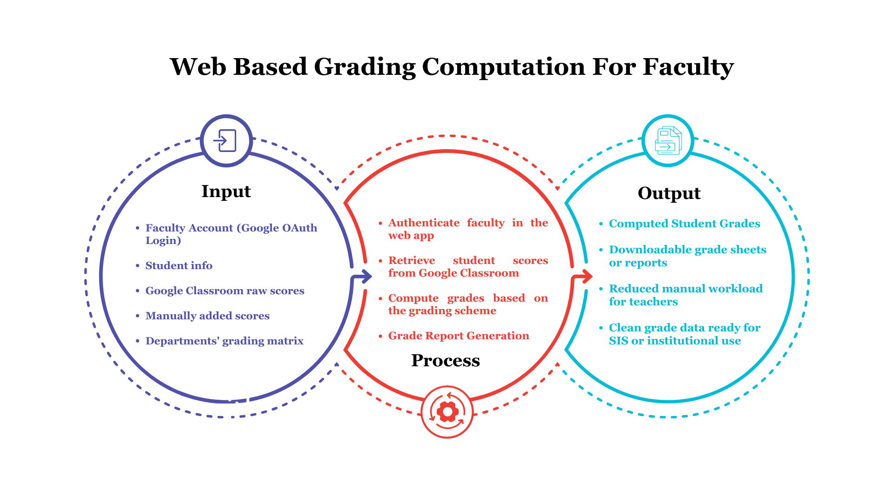
Figure 1. Conceptual Framework for the Web Application
The conceptual framework of this study illustrated how the system processed academic data through its web components. The Input included Faculty Accounts, Google Classroom raw scores, the faculty’s grading matrix, manually added activities, and student information mapped through authorized access. These inputs flowed into the Process, where the web application authenticated the faculty using their Google Account and integrated with the Google Classroom API to fetch students’ scores, and accommodated additional manually encoded scores for on-ground activities to compute grades for accurate results based on the department’s grading matrix. The system then produces computed student term and final grades and allows faculty to export the results through downloadable reports.
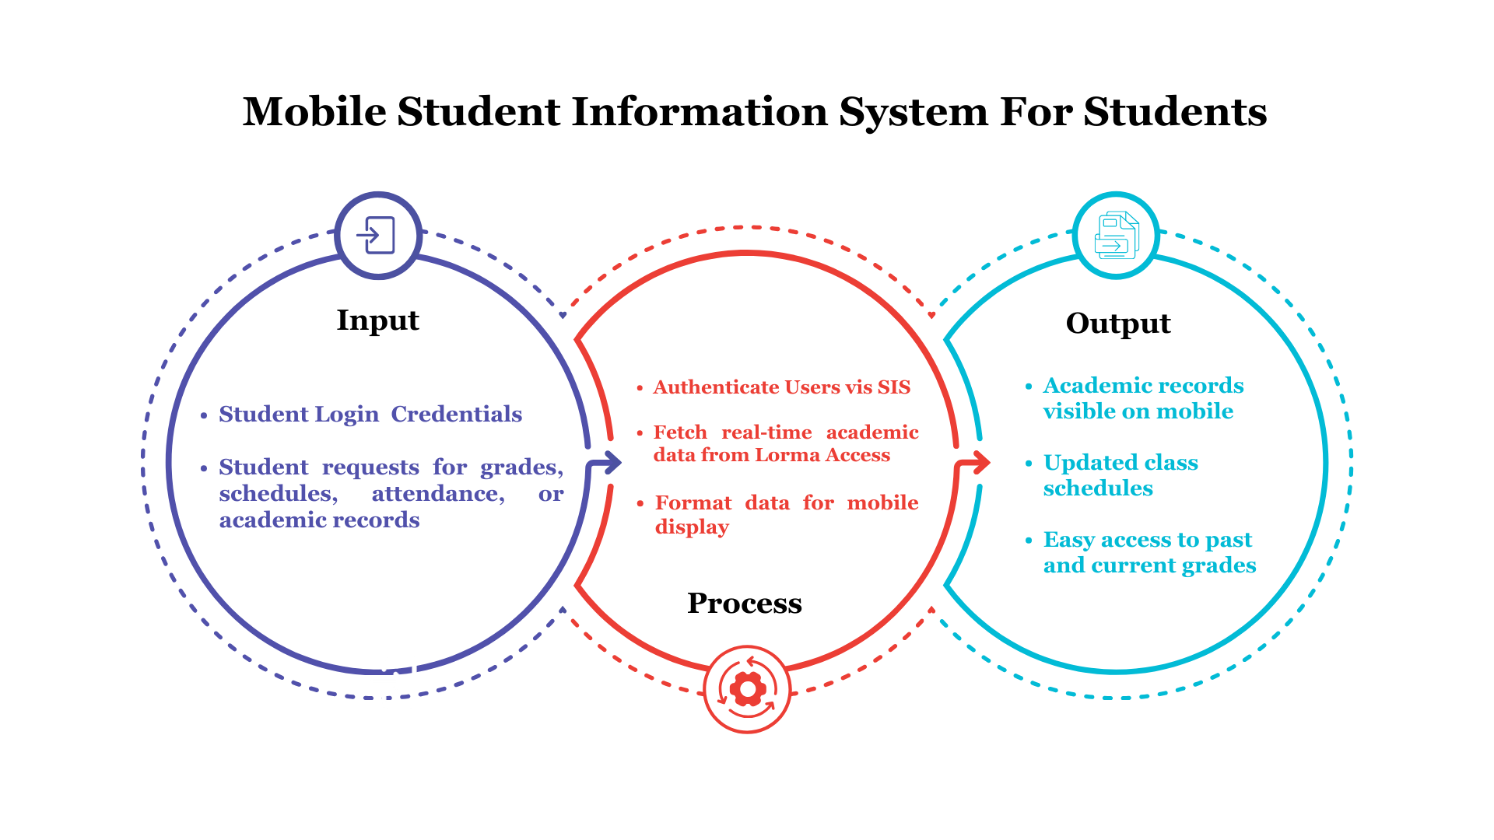
Figure 2. Conceptual Framework for the Mobile Application
For the mobile application, the framework showed how the system functioned as a dedicated viewing platform where students could conveniently access their academic information such as grades, schedules, ledger and assessment from the existing Lorma Access system. The mobile app used the Lorma Access+ API to authenticate users and retrieve real-time academic data, ensuring that students received up-to-date information on their academic performance. Beyond grades, the application also displayed other essential student-related information such as class schedules, attendance, grades, ledger and assessments. Once retrieved, the data was organized and presented in a mobile-optimized interface, allowing students to navigate their records easily and efficiently. The mobile component enhanced accessibility by delivering a seamless, user-friendly experience without altering or writing to the institutional database.
Statement of Objectives
This study was designed and developed a mobile and web application that extended the functionality of Lorma Access, the Student Information System (SIS) used by Lorma Colleges. The mobile app provided students with easier and more accessible viewing of their academic records, while the web app allowed faculty to conveniently fetch scores and compute grades from Google Classroom, streamlining the grading process and reducing manual work.
The following statements were specific objectives of the study:
- Determined the policies and procedures for grade computation, submission, and management.
- Created a mobile interface of the Lorma Access Student Information System (SIS) for students to enhance user experience.
- Developed a web application that connected to Google Classroom to fetch and compute student grades based on the faculty’s grading matrix.
- Tested and evaluated both the mobile and web applications using the System Usability Scale (SUS), focusing on measuring key usability factors such as effectiveness, efficiency, and user satisfaction, which provided insights into the overall user experience and system performance.
Scope and Limitations
This project focused on the development of LORMA Access+, which included a mobile version of the Lorma Access Student Information System for students and a web-based grading interface for faculty. It was intended to make it easier for students to view their student information, class schedules, and grades directly from the mobile application. The mobile app was available for Android only.
On the faculty side, the web application allowed instructors to connect their Google Classroom accounts and fetch students’ raw scores. The system will compute the term grades and the final rating based on each department’s grading matrix, while also providing the option to manually add scores for assessments not recorded in Google Classroom. Although the web app no longer synced directly with the LORMA Access, this change means that grade syncing to the Lorma Access Grading Sheets used by the faculties to release grades was not included. Faculty members were responsible for inputting the student’s term grades and final rating grades into LORMA Access for publication as the system functioned solely as a tool for grade computation only and did not include grade submission in the Lorma Access grade input.
The scope of this project was limited to college or higher education students and faculty within Lorma Colleges. The web application focused specifically on grade computation, and viewing of student information. Other functionalities such as assignment submissions, grade submissions, announcements, or class discussions were not covered by this project and continued to be managed through existing platforms like Google Classroom.
The system required a stable internet connection and relied on the proper functioning of both Google Classroom and the LORMA Access SIS. Any downtime or technical issues on either platform could have caused delays in fetching the scores and related data. Additionally, this project did not modify the internal structure of the existing LORMA Access system or alter how Google Classroom operated, beyond using its API to access grading data.
Purpose and Description
The purpose of this study was to design and develop a mobile application integrated with the Student Information System (SIS) of Lorma Colleges. This mobile version of Lorma Access aimed to provide students with easier access to academic records, improving convenience and accessibility beyond traditional desktop platforms. With a user-friendly and portable design, the application ensured that users could monitor their academic information anytime and anywhere using their mobile devices.
In addition, the project included the development of a web-based interface for faculty that integrated Google Classroom’s API. This integration enabled instructors to fetch student scores directly from Google Classroom and automatically compute grades once entered using the department’s grading matrix. This project benefited the following:
Lorma Colleges. The institution benefited from the implementation of the two systems: The Web-based Grading Computation System for Faculty and the Mobile Lorma Access Student Information System for Students. The project supported Lorma Colleges’ digital transformation by providing a more organized, efficient, and centralized academic system.
Students. The primary users of the mobile app. Through this mobile application, students gained convenience that allowed students to monitor their real-time access to their academic records, especially their grades. The app also allowed students to monitor their progress anytime and anywhere using their mobile devices.
Teachers and Faculty Members. The web interface helped make grading easier by letting teachers fetch scores directly from their Google Classroom with just one action. Once the scores were fetched, the system computed the grades based on their grading matrix. The system also provided an option to manually add other scores that were not recorded in Google Classroom.
Researchers. This study served as a reference for researchers interested in academic information systems, grading computation systems, and the integration of web and mobile technologies in educational environments. The findings, system design, and implementation may provide insights and support further studies related to educational technology and system development.
Future Researchers. The project may be used as a foundation for future studies aiming to enhance or expand similar systems. Future researchers may improve the system.
Technical Background
The study made use of several key technologies in the development of the mobile application aimed at enhancing accessibility. A detailed enumeration of the tools used, along with their specific applications to the project, was provided below:
Flutter. The researchers chose Flutter as the primary technology for building their mobile application because flutter provides a smooth performance on Android devices. Since the project focused on mobile accessibility, Flutter’s cross-platform nature allowed the researchers to develop one codebase that reached users regardless of their device, saving both time and resources.
Laravel. The researchers used Laravel, a popular PHP framework, for backend development. It facilitated efficient routing, authentication, and database management. The framework's built-in features streamlined the development process, making it an excellent choice for creating a reliable backend system.
Dart. The researchers used Dart, the primary programming language associated with Flutter, to enable swift development and a well-structured code architecture. Dart supported the execution of frontend logic and the rendering of the user interface in the mobile application, promoting efficient coding methodologies and enhancing maintainability.
Visual Studio Code. The researchers used Visual Studio Code as the main source code editor for the project because its lightweight and flexible design, combined with built-in tools and extensions, greatly improved productivity in the development of Flutter and Laravel.
Git & GitHub. The researchers used Git as the version control system to monitor code modifications during the development process. It enabled smooth collaboration and version control among team members.
Figma. The researchers utilized Figma, a cloud-based design and prototyping platform, which enabled them to collaborate on UI/UX design in real time. Figma allowed the researchers to collaboratively edit, prototype, and verify that the visual components were in harmony with the overall application design.
Google Classroom API. The researchers used the Google Classroom API to allow the system to securely connect to teachers’ Google Classroom accounts and fetch student scores. This integration made it possible to fetch raw grades, which the web interface then processed and computed.
Kiro. The researchers used Kiro as the primary integrated development environment for the system. Kiro assisted developers in identifying, analyzing, and resolving errors in the web application during the development process. By providing detailed insights into code execution and potential issues, Kiro enhanced the system’s stability and reliability.
CHAPTER II
DESIGN AND METHODOLOGY
In this chapter, the researcher discussed the methods that were used to guide the development, implementation, and evaluation of the Lorma Access+ project. This included a detailed explanation of the research design, population and locale, data-gathering tools, and procedures that supported the creation of both the mobile version of the Student Information System (SIS) and the grade synchronization feature with Google Classroom.
Research Design
The research design for Lorma Access+: Enhancing Grade Processing and Student Accessibility Through a Web and Mobile Application used a mixed-method design, combining both quantitative and qualitative methods. This design allowed the researchers to provide a clearer understanding of user needs, system performance, and the overall impact of automation and mobile access on academic processes.
The quantitative part of the research involved collecting data through surveys and analyzing how participants used the system. This helped measure how much time was saved, how satisfied users were, and how efficient the new setup was compared to the previous one. Quantitative data allowed the researchers to identify measurable impacts of the system on academic operations, particularly regarding the fetching and computation of grades from Google Classroom.
On the qualitative side, the researchers conducted interviews, focused on group discussions, and observations with students and faculty members. This provided deeper insights into user experience, satisfaction, and the real-world challenges users faced when using both the mobile system and the grade processing feature. Both qualitative insights and quantitative measures were used to define user pain points and inform the system requirements.
By applying a mixed-method approach, the project provided a complete view of how the Lorma Access mobile app and the web grade computation system impacted users and academic processes. The mixed-method approach combined both numerical data and personal feedback to evaluate the effectiveness of each feature in real settings. This approach also helped determine whether the mobile version of the SIS improved accessibility for students and faculty, and whether the automated grade sync effectively reduced the time and effort spent on manual grade encoding.
Population and Locale
The study was conducted at Lorma Colleges, located in San Fernando City and San Juan, La Union, Philippines. The participants in this study included a total of thirty (32) respondents. During the pre-developmental phase, five (5) students, four (4) faculty members, and one (1) system administrator were interviewed to provide input on how the system could be designed to meet their needs. After the system had been developed, a separate group of respondents, composed of fifteen (15) students and seven (7) faculty members, participated in the System Usability Scale (SUS) survey to assess its overall usability and user satisfaction. These respondents were selected because they were directly involved with the system and could provide valuable insights into its usability and functionality. Purposive sampling was used to select the respondents, as they were intentionally chosen based on their direct experience with the system. This nonprobability sampling method enabled the researchers to purposely choose individuals who were most relevant to the study's goals, ensuring that the data collected was both useful and focused (Nikolopoulou, 2023). This sampling method ensured that the feedback gathered was highly relevant to the objectives of the study, focusing on those who were most familiar with the current challenges and potential improvements to the Lorma Access.
Table 1. Distribution of Respondents
Respondents |  | No. Of Respondents
Students  Faculties  System Admin |  | 20  11  1
 |  | Total: 32
The students were selected as the primary users of the Lorma Access mobile version, as they relied on the Lorma Access SIS to access their academic information such as the students grade, schedule, assessments and transactions. Their feedback was essential in understanding how well the system functioned from the student perspective, particularly regarding its ease of use and mobile compatibility. The faculty members were chosen because they were responsible for entering and managing grades in the system. Their input was valuable in refining the grade computation process and ensuring the system was effective for teaching staff. The system administrator was included for their expertise in the technical aspects of the system, providing a crucial perspective on its potential limitations and areas for improvement.
The researchers acknowledged that the information gathered, especially regarding participants' experiences with the Lorma Access Student Information System (SIS), might have been sensitive. The researchers ethical considerations are to protect the respondents, all data was kept confidential and was not shared with any unauthorized individuals. The researchers ensured that clear consent was obtained from everyone taking part in the study. Participation was completely voluntary, and all answers remained anonymous to protect participants’ privacy. The information collected was safely stored and used only for this research. Additionally, the study was conducted with fairness and objectivity, focusing on providing accurate and trustworthy insights. Respondents were also informed that the participants could withdraw from the study at any time without experiencing any penalties or negative consequences.
Data Gathering Tools and Procedure
The first objective was to identify and define the policies and procedures involved in grade computation, submission, and management of instructors at Lorma Colleges. This included outlining the standard workflow for handling grades, ensuring accuracy and consistency, and establishing guidelines that supported secure and efficient grade processing. To support this objective, the researchers interviewed faculty members to gather insights into their existing practices, challenges, and requirements. The procedure also recognized the role of the Registrar’s Office in grade management, particularly in receiving, verifying, and officially recording the submitted grades. Their feedback helped the researchers establish guidelines and workflows that complied with institutional standards and ensured smooth integration with existing processes.
The second objective was to create a mobile interface of the Lorma Access Student Information System (SIS) for students to enhance user experience. The researchers utilized a pre-development survey questionnaire (see Appendix B) to gather feedback from students regarding their preferences and expectations for a mobile-friendly interface. The questionnaires focused on factors such as ease of navigation, preferred features, and design preferences. The responses helped design the mobile interface, address the students' concerns, and tailor the features to meet their demands.
The third objective focused on developing a web-based interface that enabled faculty members to fetch student grades from Google Classroom and compute the term and final grades of students. It significantly reduced the need for manual score entry and the use of intermediary spreadsheets. To ensure the interface addressed real-world needs, the researchers interviewed faculty and system administrator (see Appendix B) to better understand their current workflows and challenges. These insights guided the development of a solution that improved efficiency, reduced errors, and better aligned with existing practices.
For the fourth objective, the researchers used the System Usability Scale (SUS) to evaluate both the mobile application and the web grade computation feature from Google Classroom. The SUS helped measure usability, efficiency, and user satisfaction from the perspectives of students, faculty members, and system administrators.
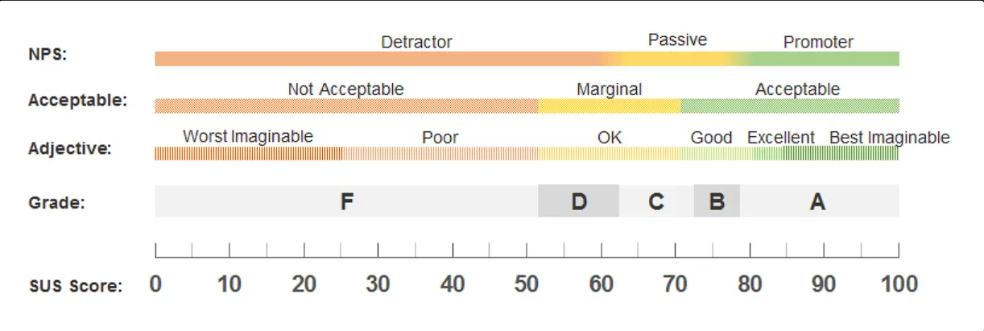
Figure 3. System Usability Scale (SUS) Score Interpretation
Figure 3 illustrated the summary of the SUS scores, which allowed the researchers to gain an immediate overview of user perceptions. The SUS served as an effective usability tool for assessing the system’s ease of use, guiding the researchers in identifying which parts needed improvement to make the system clear and enjoyable for its target audience.
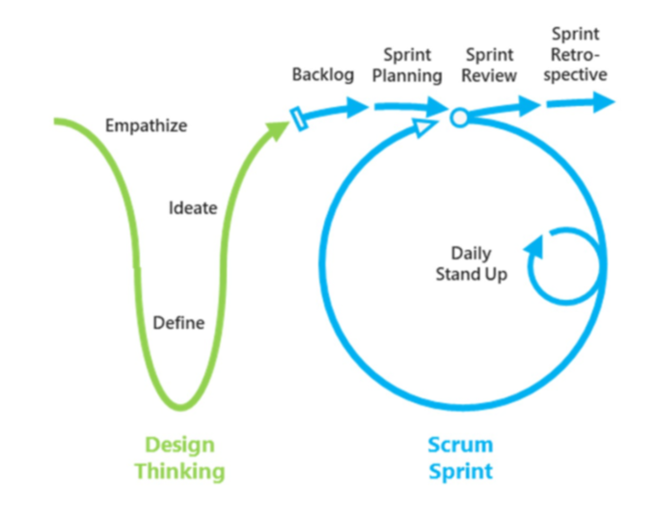
Software Methodology

Figure 4. Design Thinking and Scrum Methodology
For the development of the mobile interface of the Lorma Access Student Information System (SIS) and web grade computation integration for the faculties, the researchers adopted a combination of Design Thinking and Scrum methodologies. This hybrid approach was chosen to support user-centered design and enabled flexible, iterative development, allowing the team to adapt quickly based on user feedback and evolving requirements.
Design Thinking focused on understanding the users' needs and redefining problems through empathy and creative problem-solving (Han, 2022). The process was composed of five phases, which the researchers applied as follows:
Empathize
The researchers gathered interviews using their set of questionnaires (see Appendix B) from the primary users of the system. The aim was to better understand their struggles, expectations, and frustrations with the current web-based SIS and how grades were managed. To do this, they used a mix of interviews, surveys, and real-time observation of how users interacted with the platform in their day-to-day activities.
Define
Once the data was gathered, the researchers carefully analyzed and organized the findings to pinpoint the main problems users were facing. These included issues such as trouble accessing the Lorma Access on the web using their mobile devices or the manual input of scores from Google Classroom. This phase provided a clear understanding of the problems and helped establish the goals for the development of the new system.
Ideate
In this phase, the researchers brainstormed a wide range of ideas and potential solutions to address the identified issues. Concepts such as a more user-friendly, mobile-optimized interface and web grade computation were explored. These ideas were refined and prioritized based on user feedback and what was technically feasible.
Prototype
The researchers created prototypes based on the ideas they had gathered. These prototypes consisted of simplified versions of the mobile interface and the web-based grade computation feature. Users had the chance to test these prototypes, providing feedback that helped refine the features before moving on to full-scale development.
Test
Lastly, the prototypes were tested by a select group of students, faculty, and system administrators. The feedback gathered from these users helped identify usability issues and areas that needed further refinement. This ensured that the final version of the system was both functional and tailored to meet the real-world needs of the users.
After completing the Design Thinking phases and gathering essential insights, the development transitioned into the Scrum methodology, which supported iterative development, flexibility, and continuous feedback. Scrum helped the researchers effectively transform the identified problems, user feedback, and prototypes into a fully functional product (ScrumStudy, 2024).
In Scrum, the development process was divided into short iterations called sprints, typically lasting 2 to 4 weeks. The goal of each sprint was to deliver a usable product increment (ScrumStudy, 2024). Here’s how the Scrum process was applied to this project:
Sprint Planning
At the beginning of each sprint, the researchers conducted a Sprint Planning meeting to define and prioritize tasks that aligned with the two main goals of the project: developing a mobile-friendly version of the Lorma Access Student Information System and developing a web-based grade computation feature using the Google Classroom API. The researchers went through the list of tasks, sorted out what was most important, and planned what could realistically be finished within the sprint timeline.
Daily Stand-ups
Throughout the sprint, the researchers held brief daily stand-up meetings to provide quick progress updates and maintain alignment among team members. During these meetings, the researchers shared the tasks they were working on, reported any issues encountered, such as bugs in the mobile interface or problems with the web-based system, and received assistance when necessary. These meetings served as an efficient method to ensure the project progressed smoothly.
Development & Testing
During the sprint, the researchers focused on developing the mobile interface for students to use and the web-based grade computation feature for faculty members. Each feature was tested immediately after development to identify and resolve issues at an early stage. This process corresponded with the Test phase of Design Thinking, in which feedback from students, faculty, and administrators was collected to ensure that the system was user-friendly and addressed the practical needs of its users.
Sprint Review
At the end of each sprint, the team held a Sprint Review to present the latest version of the mobile app and the web-based grade computation feature to the stakeholders. During this review, feedback from faculty, students, and system administrators was gathered to assess the progress and identify areas for improvement. This feedback then informed the next sprint, allowing the team to make necessary adjustments to the system.
Sprint Retrospective
After the Sprint Review, the researchers held a Sprint Retrospective. In this meeting, the team reflected on the sprint, discussing what went well, what could be improved, and what changes should be made for the next sprint. This continuous improvement process helped ensure that the development remained efficient and responsive to both user needs and team dynamics.
CHAPTER III
RESULTS AND DISCUSSION
In this chapter, the researchers discussed the results of the study. It presented the objectives of the project and explained the outcomes of the developed system based on the statements of the objectives stated in Chapter I.
Determined the policies and procedures for the process for grade computation, submission, and management.
This objective was achieved by thoroughly examining and documenting the existing policies and procedures, including the computation, submission, and management of student grades handled by instructors at Lorma Colleges. The researchers conducted interviews with faculty members across different departments. The findings revealed that instructors continue to rely heavily on spreadsheets and manual encoding for nearly all grading-related tasks. Faculty members input raw scores for quizzes, assignments, activities, and examinations into spreadsheets, which they also use to compute term grades and final ratings. The grading process is manual, requiring instructors to calculate results independently and ensure accuracy before transferring the computed grades into the institutional system.
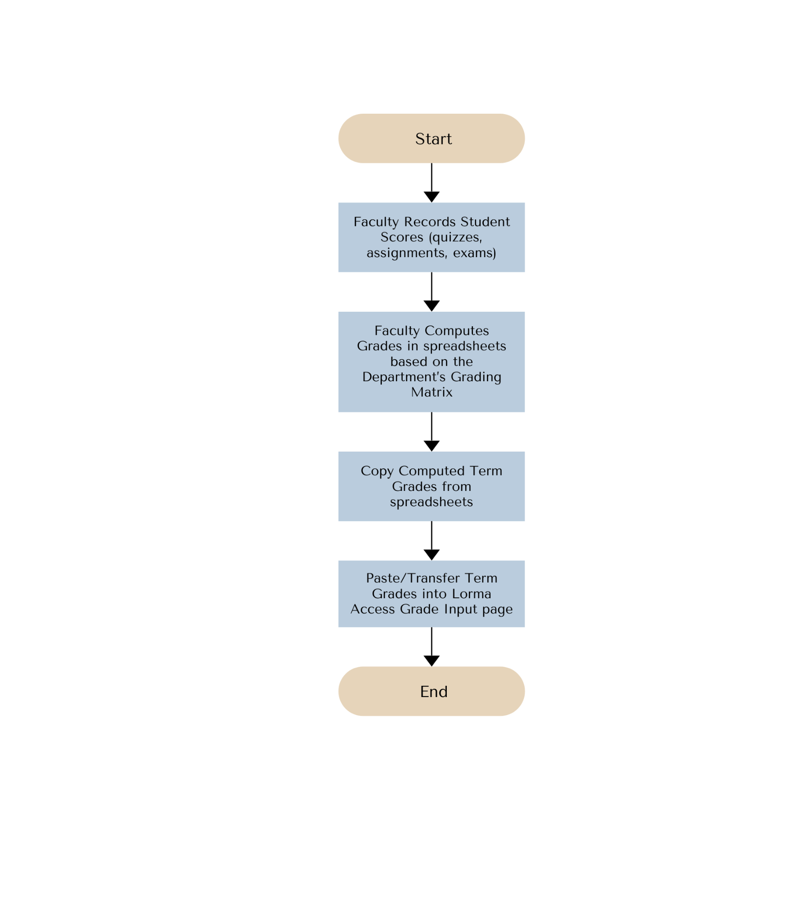
Figure 5. Procedure for Computation and Submission of Term Grades Flowchart
Figure 5 illustrates the flowchart for computing the students’ term grades. In computing the student’s term grades, faculty members begin by recording the students scores and then transferring them into the spreadsheets following the department’s grading matrix to ensure consistency and accuracy in each student's term grades. Once the computations are finalized and verified, the instructor proceeds to transfer the computed term grades by copying and pasting the computed term grades into the Lorma Access term grade input page, where the grades are prepared for official submission and record-keeping.
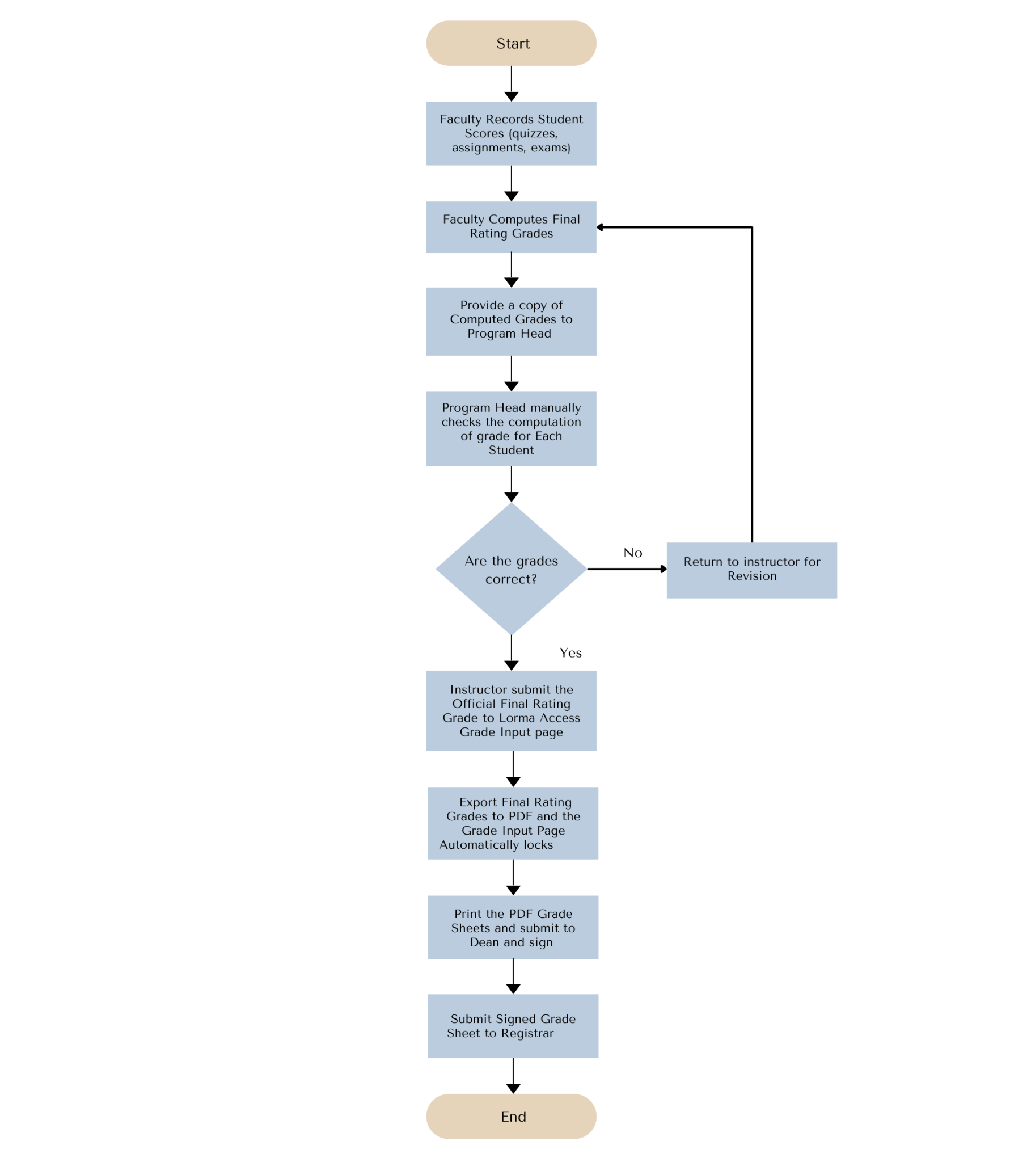
Figure 6. Procedure of Submission of Final Rating Grade Flowchart
Figure 6 illustrates the flowchart for the procedure in Submission of Final Rating Grade. Before submitting the final grades, the instructor first provides a copy of the computed grades to the Program Head. The Program Head then manually double-checks each student’s grade to ensure that all computations are accurate. Once the verification is completed, the instructor proceeds with the official submission. After submitting and exporting the grades into a PDF, the grade input page in Lorma Access is automatically locked. The instructor then prints the PDF, secures the dean’s signature for validation, and submits the signed grade sheet to the Registrar’s Office.
In cases where a computational error is discovered after submission, the faculty member must file a formal request letter to have the Lorma Access grade input page unlocked. If approved by the Registrar, the grade input page was unlocked, allowing the instructor to correct the error. After changes are made, the instructor followed the same procedure in submitting the final grade
Current policies emphasize accuracy of grades prior to submission, confidentiality of student records, and strict compliance with institutional deadlines.
Created a mobile interface of the Lorma Access Student Information System (SIS) for students to enhance user experience.
This objective was achieved by creating a mobile interface of the Lorma Access Student Information System (SIS) to enhance the student user experience. The researchers designed and developed a mobile application that provides students with easy access to their academic records, including grades, class schedules, and other relevant information. The interface was built following user-centered design principles, focusing on intuitive navigation, responsiveness, and clarity of information display.
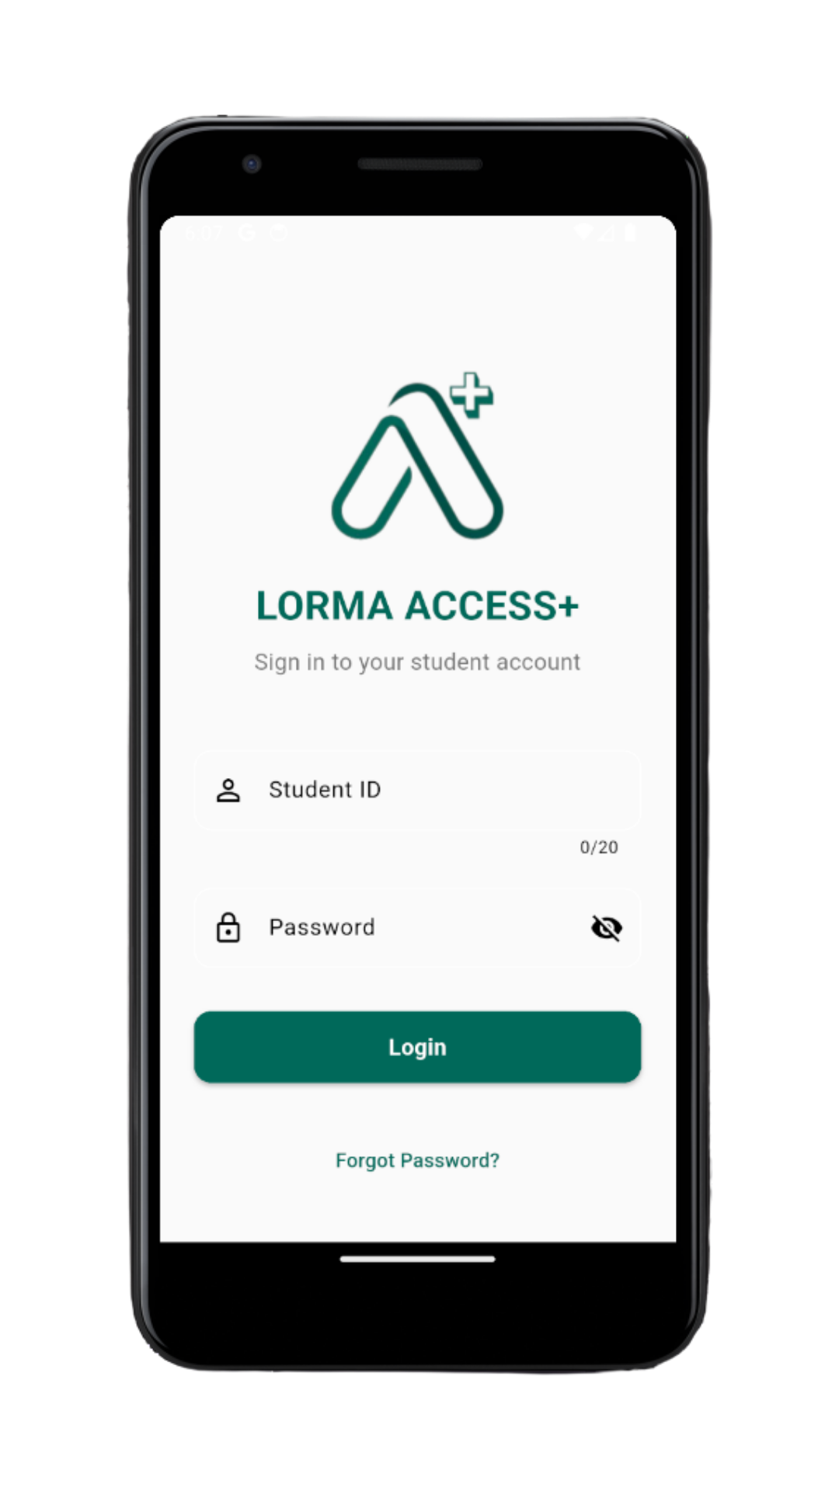
Figure 7. Login Page

Figure 7 (see page 30) showed the Login Page, which served as the secure access point for the mobile version of the Lorma Access SIS. Students were required to enter their student ID and password to authenticate their identity before accessing the system. This page ensured that academic records remained confidential and protected from unauthorized access.
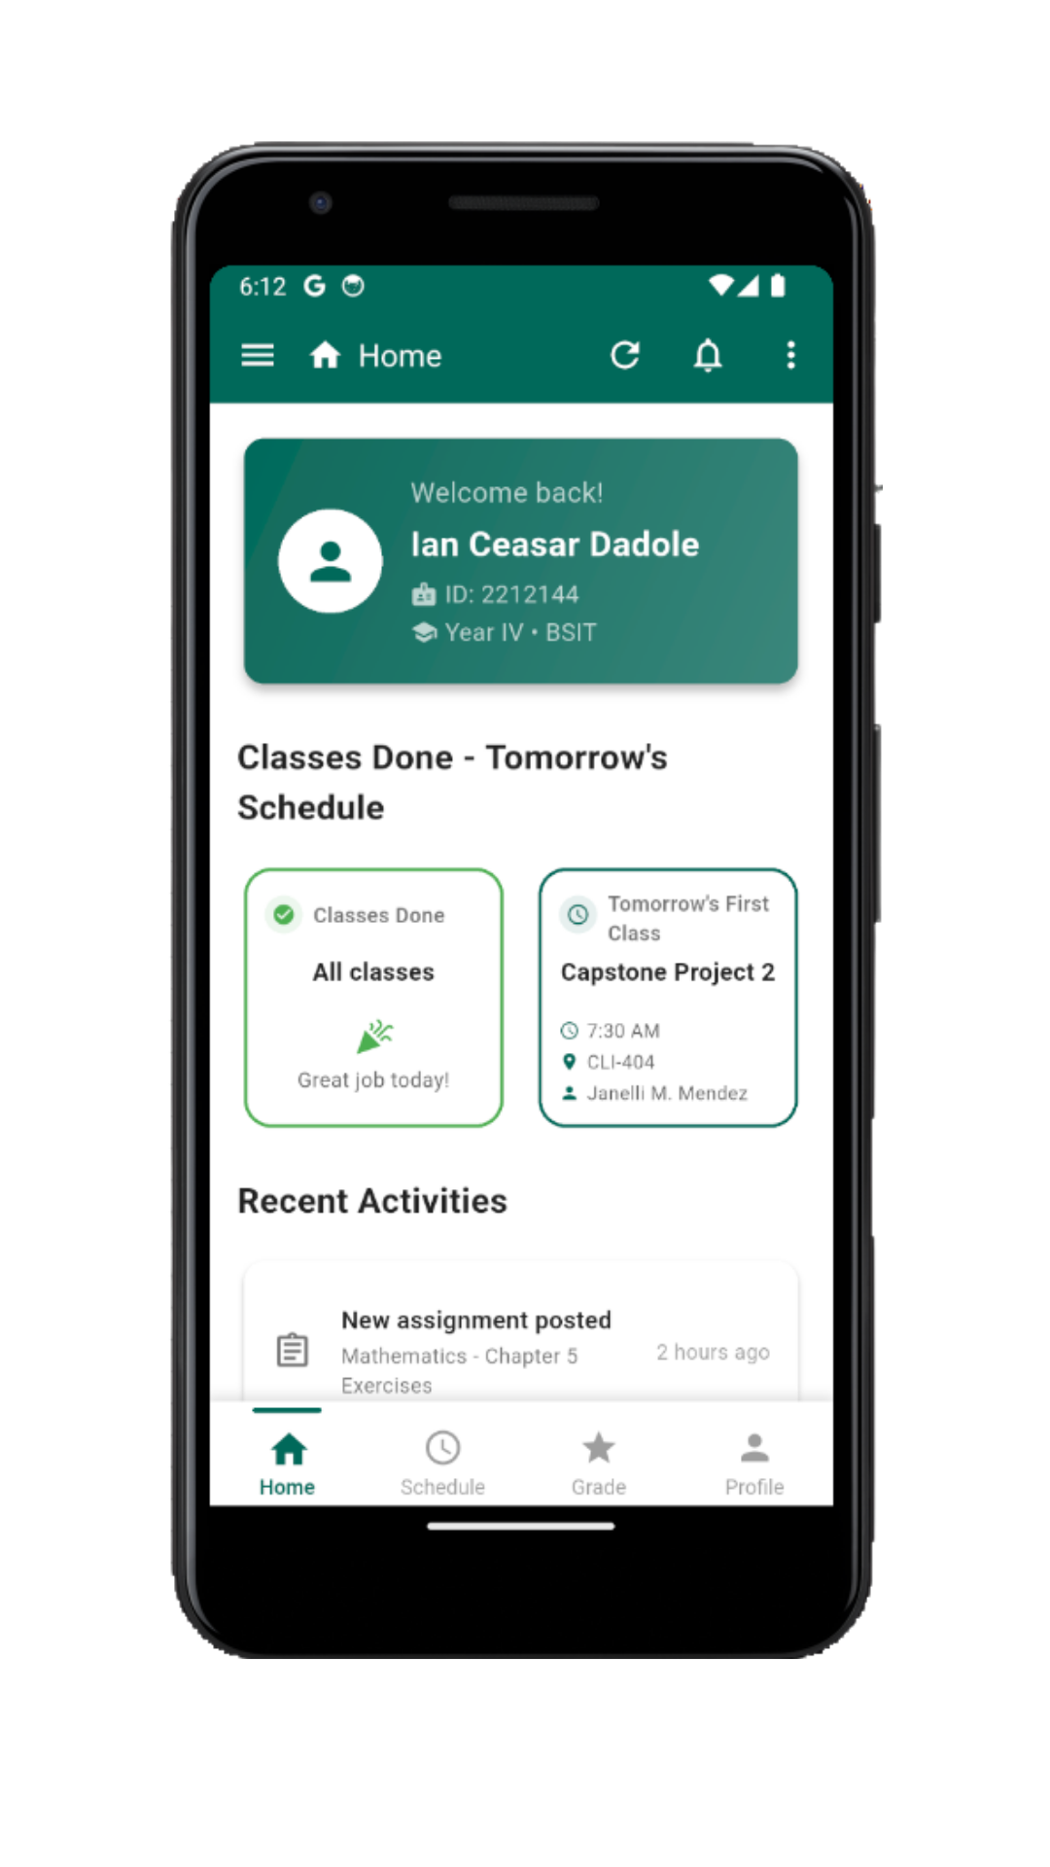
Figure 8. Home Page
Figure 8 illustrates the Home Page (see page 31), which functioned as the primary dashboard of the mobile application. The Home Page presented a concise view of the student’s class schedule and an overview of essential academic information, facilitating efficient navigation within the application.
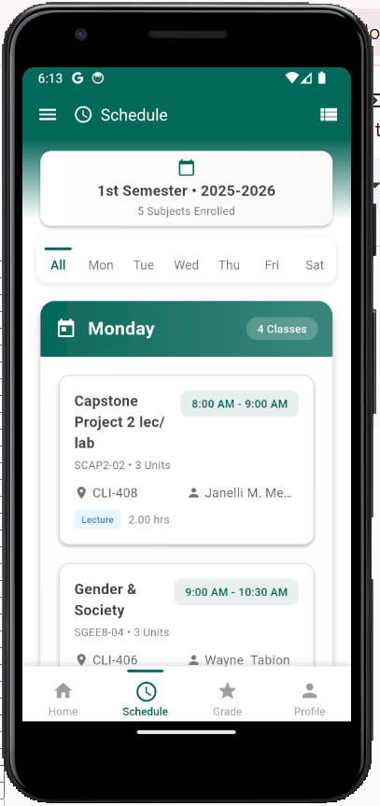
Figure 9. Schedule Page

The Schedule Page (Figure 9) presented a clear and detailed layout of the student’s class schedule, including subjects, instructors, time slots, and room assignments. This page helped students keep track of their daily and weekly academic activities.
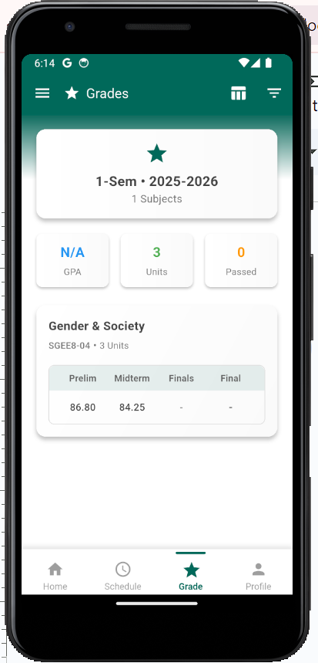
Figure 10. Grades Page

Grades Page (Figure 10) displayed the student’s academic performance, showing grades for each subject and semester. It allowed students to conveniently monitor their progress without navigating through the full web-based SIS.
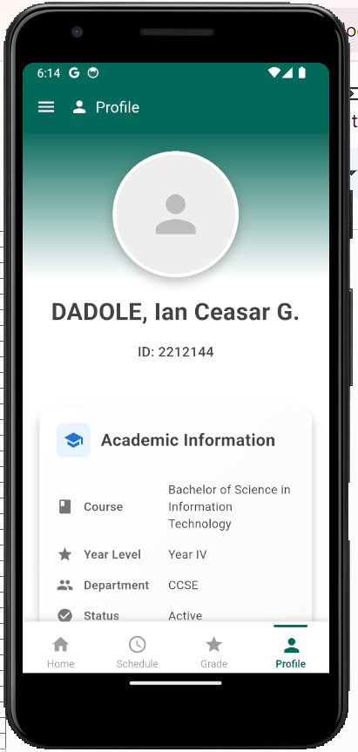
Figure 11. Profile Page
Figure 11 illustrates the Profile Page, which contains the student’s personal information, including name, student ID, course, and other relevant details. The Profile Page enabled students to review their records and verify the accuracy of their profile information.
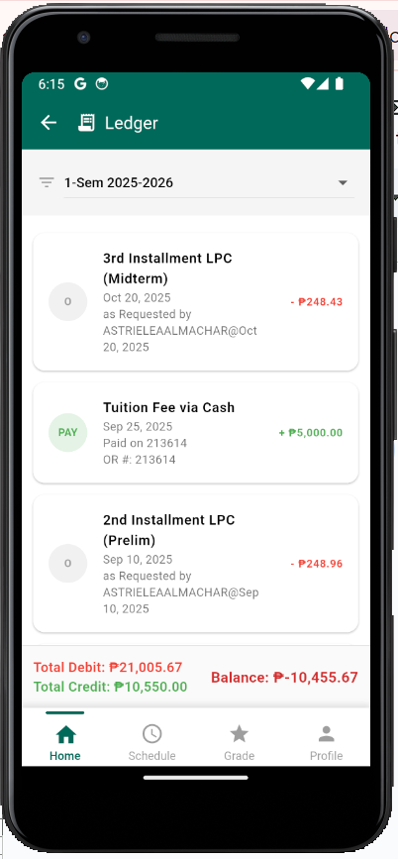
Figure 12. Ledger Page

The Ledger Page (Figure 12) provided a detailed view of the student’s financial records, including outstanding balances, previous payments, and overall account status. The Ledger Page supports better financial transparency for students.
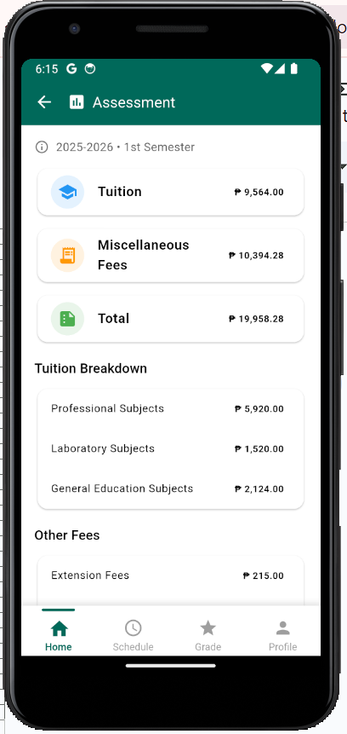
Figure 13. Assessment Page

Figure 13 illustrates the Assessment Page, which provides a detailed breakdown of the student’s tuition and miscellaneous charges. The Assessment Page enables students to understand their billing information and access their assessment forms directly through the mobile application.
Developed a web application that connects to Google Classroom to fetch and compute student grades based on the faculty’s grading matrix, serving as a standalone tool to streamline the grading process.
This objective was achieved to develop a web-based grading interface for faculty that integrates directly with Google Classroom to fetch and compute the student grades.
The researchers developed a system that allows faculty members to securely connect their Google Classroom accounts and import students’ raw scores with minimal effort. Once the data is fetched, the web applies the institution’s grading matrix to compute term grades and final rating.
The web interface was designed to improve faculty efficiency by reducing manual encoding, minimizing computational errors, and centralizing grading tasks. Built with an intuitive and organized layout, the system ensures smooth navigation, accurate grade processing, and a streamlined workflow for instructors managing multiple classes. The following web pages were developed by the researchers to support these functions:

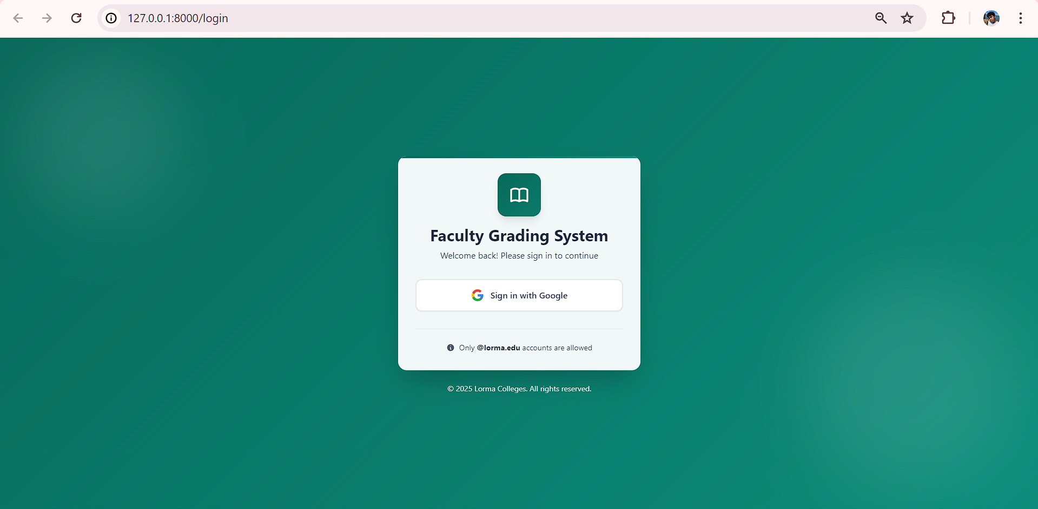
Figure 14. Login Page
The login page (Figure 14) served as the secure authentication gateway for instructors accessing the web-based grading system. The system was integrated with Google Classroom, and faculty members logged in using their Google Account credentials to ensure authorized and seamless access. The page featured a simple interface with a “Sign in with Google” button that initiated the Google OAuth process, allowing the system to verify the faculty identity and grant permission to fetch class information and student scores. Once authenticated, faculty members were redirected to the main dashboard where they could map students and classes, fetch Google Classroom scores, input additional assessments, and perform grade computations based on the department’s grading matrix.
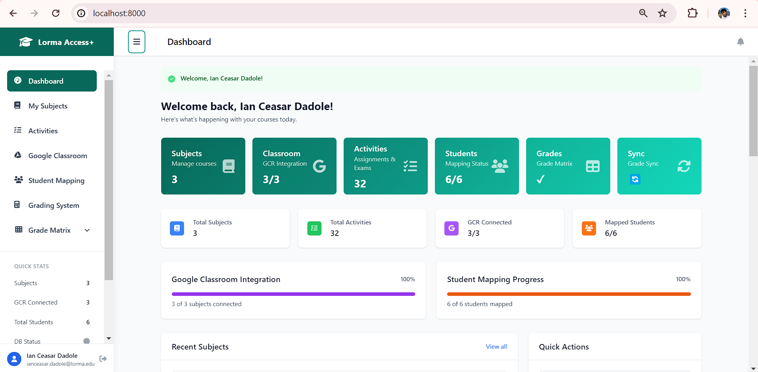
Figure 15. Dashboard Page
The Dashboard Page (Figure 15) provided instructors with an organized overview of the system’s core functionalities. After successfully logging in using their Google Account, faculty members were directed to this interface. The dashboard acted as the starting point for all grading-related activities, ensuring that faculty could efficiently perform tasks and access features without unnecessary steps.

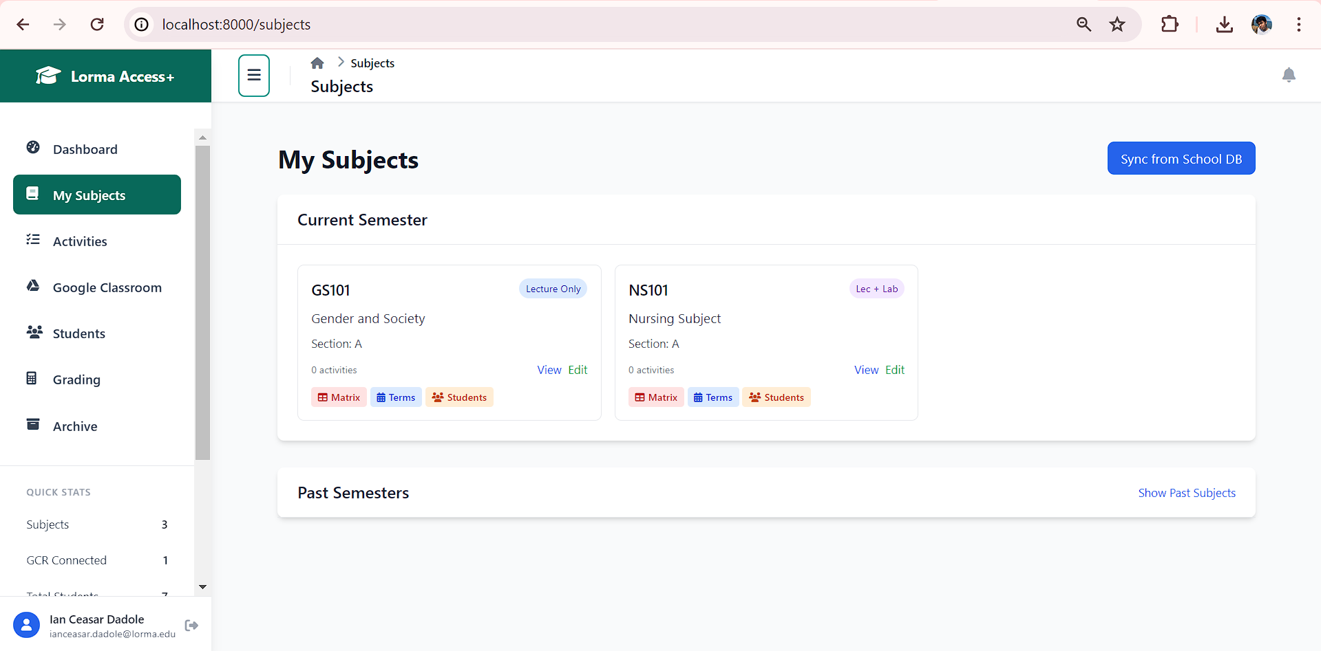
Figure 16. My Subjects Page
Figure 16 is the Subjects Page which displays all subjects assigned to a faculty member based on the database. Through this page, instructors could view each subject along with the list of enrolled students. The Subjects Page provided an organized overview of the faculty member’s teaching responsibilities, enabling easy selection of a subject to perform tasks such as activity management, student mapping, score entry, and grade computation. The Students Page functioned as the primary navigation point for managing assigned classes, ensuring that all subject and student information remained consistent with the institution’s official records.
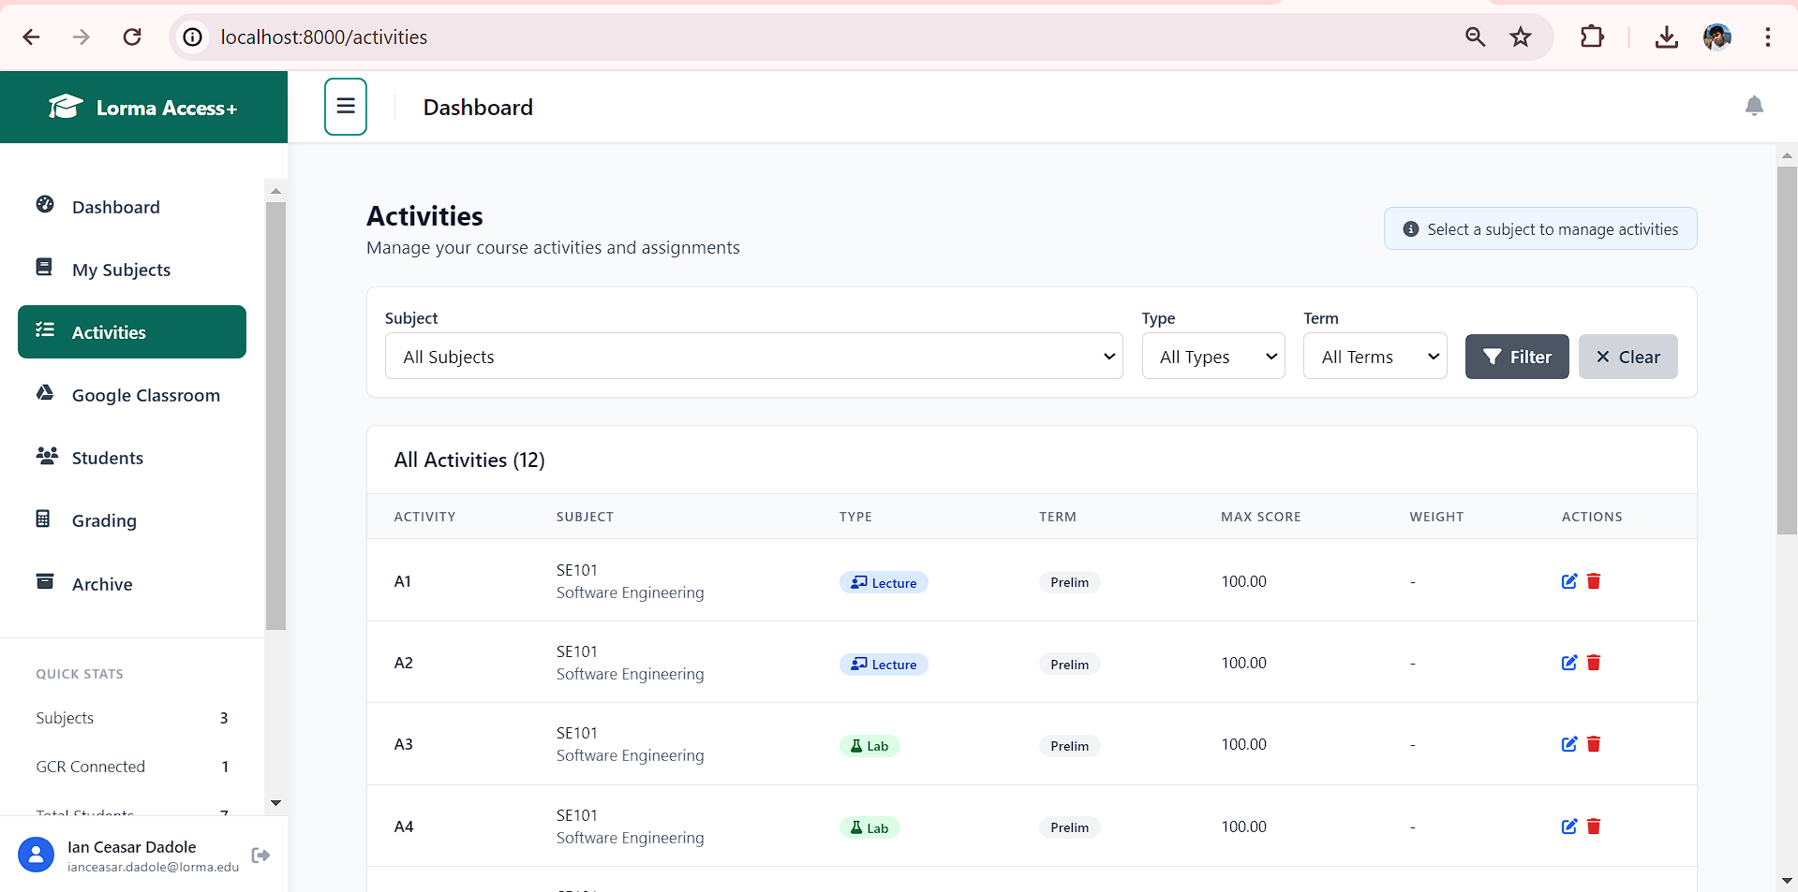
Figure 17. Activities Page
The Activities Page (Figure 17) is where faculty members manage all course assessments, including both Google Classroom fetched activities and manually added non-GCR or onsite activities. This page provides instructors with a unified view of all tasks, enabling them to review imported Google Classroom activities and create additional assessments that are not part of the Google Classroom environment. The Activities page helps ensure that all activities contributing to the students’ grades are properly recorded and maintained within the system.
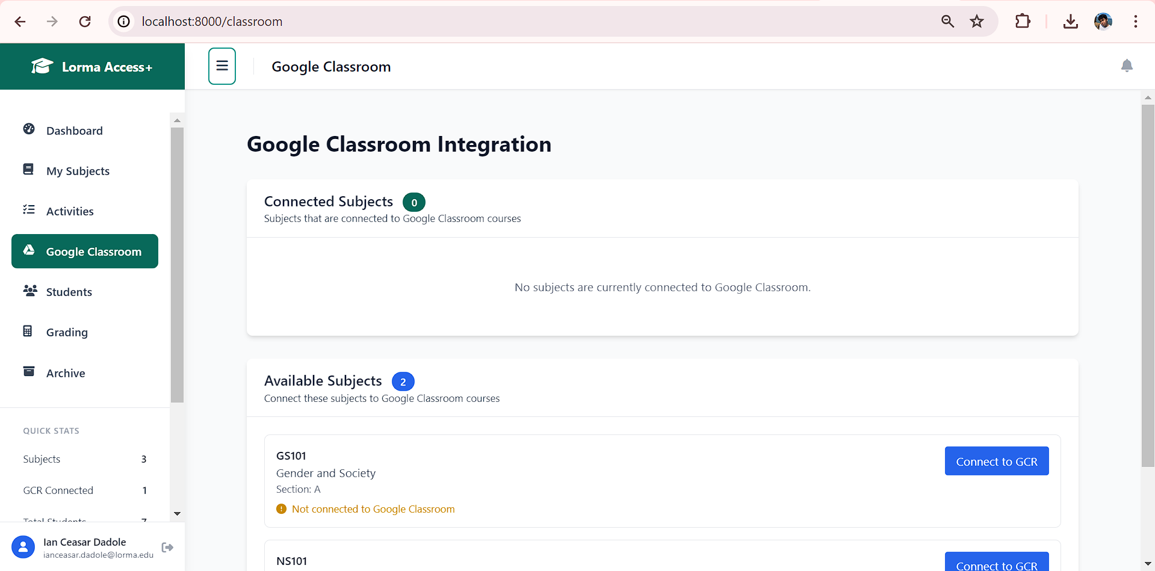
Figure 18. Google Classroom Integration Page
The Google Classroom Integration Page (Figure 18) allows faculty members to connect the subjects assigned to them in the system with the corresponding classes they have created in Google Classroom. Through this page, instructors can map each subject to its appropriate Google Classroom course, ensuring accurate alignment between the system’s subject list and the classes stored in Google Classroom.
Once the mapping is completed, the system can correctly identify which Google Classroom course to pull data from during score retrieval. This setup ensures that all imported activities and scores correspond to the correct subject before proceeding to other processes such as student mapping and grade computation.
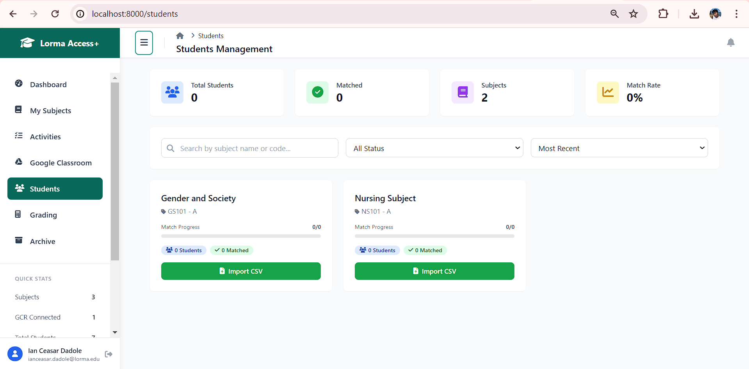
Figure 19. Students Page
The Students Page (Figure 19) is where faculty members import the CSV file exported from the class roster in Lorma Access and match the listed students with those who have joined the corresponding Google Classroom class. Since Google Classroom and the imported CSV may store student information differently, this page provides a dedicated interface to automatically match students, accurately pairing each student profile. Faculty can review the students fetched from Google Classroom and match them with the correct student records imported from the CSV. This ensures that all scores imported from Google Classroom are assigned to the correct student within the grading system. Proper mapping on this page is essential for accurate score integration, activity tracking, and grade computation.

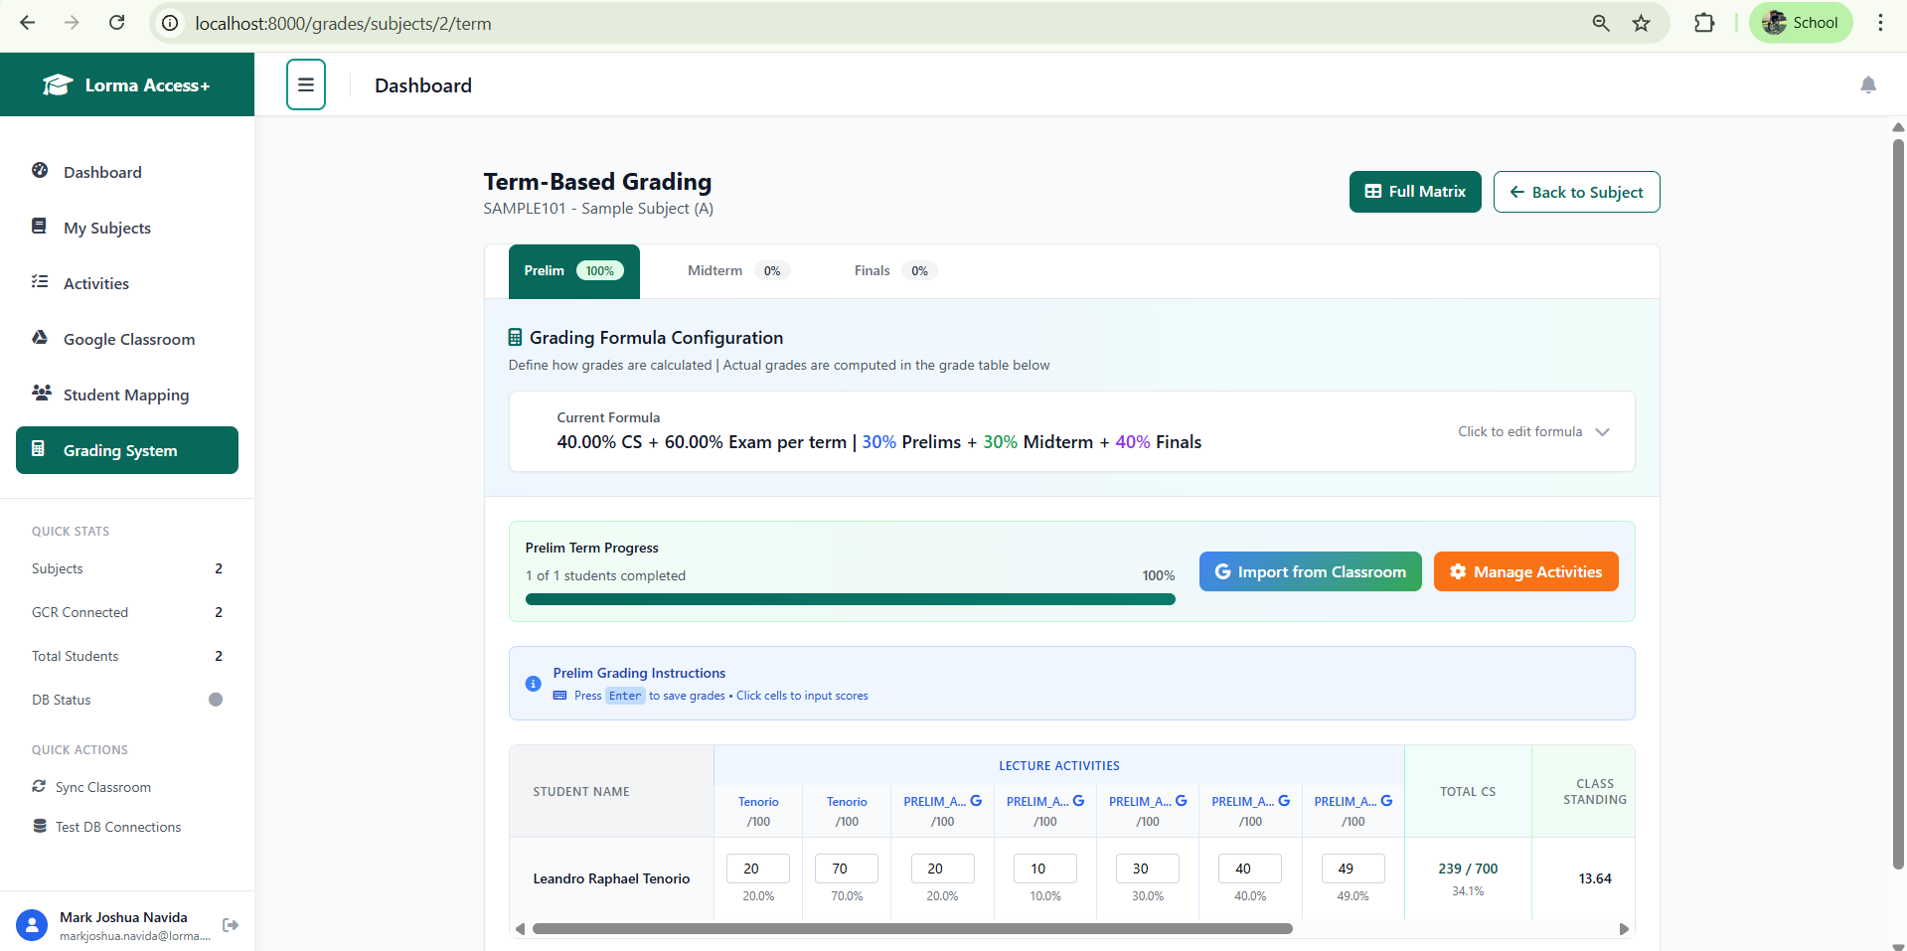
Figure 20. Grading Page
The Grading Page (Figure 20) is where faculty members input the activity scores of students, including both scores fetched from Google Classroom and scores from onsite or manually conducted assessments. The page displays all Google Classroom activities alongside non-GCR assessments, allowing instructors to review, update, and complete each student’s score records.
In addition, faculty can customize the components of the table and configure the formulas used in their department, making the system dynamic and adaptable to different grading practices. Once all scores are entered, the system automatically computes the students’ grades based on the department’s grading matrix for each term and the final grade. After the term grade and final rating are generated, the faculty then copy the computed grades from the system and manually paste them into the grade entry page of Lorma Access. Overall, this page ensures that all assessment data, whether online or onsite, is accurately reflected in the computed results, supporting efficient, flexible, and consistent grading workflows for faculty members.
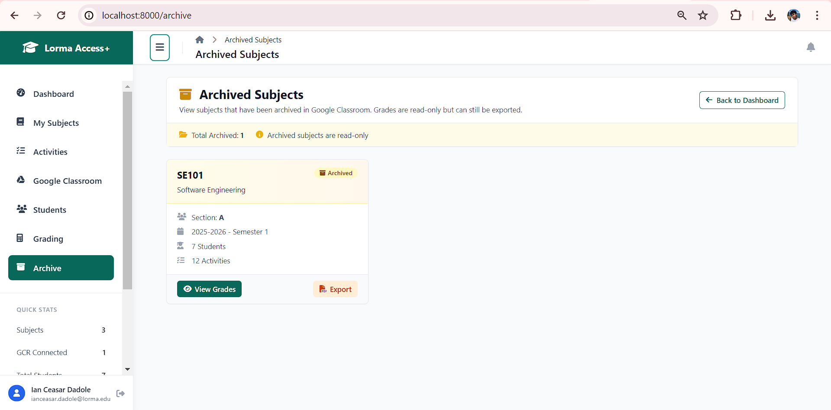
Figure 21. Archive Page
The Archive Page (Figure 21) serves as a centralized repository for classrooms that have been archived in Google Classroom. Once a classroom is archived, the corresponding class is automatically listed in this page, ensuring that faculty members have easy access to past records. On the Archive Page, faculty can view detailed information about the archived subjects, including the list of enrolled students, their submitted activities, and final grades. This feature allows instructors to review historical data, track student performance over time, and reference previous academic records as needed. By consolidating archived classrooms and their associated student records in one location, the system provides an organized and efficient way to manage past classes while maintaining the integrity and accessibility of academic information.
Tested and evaluated both the mobile application for students and web application for faculties using the System Usability Scale (SUS), focusing on measuring key usability factors
For the fourth objective, the usability of both the mobile application for students and the web application for faculty members was evaluated using the System Usability Scale (SUS). SUS was used to assess how easy, efficient, and user-friendly each platform is by measuring core usability factors such as ease of use, learnability, system consistency, and overall user satisfaction. Participants completed the SUS questionnaire after interacting with the system of both mobile and web applications.
Usefulness
The researchers conducted a usability assessment of both the mobile and web applications using the System Usability Scale (SUS). The usability questionnaire was administered through Google Forms, allowing users to interact and experience the system before providing feedback. The responses gathered from Google Forms were organized then processed to compute the SUS raw scores and the final SUS scores, as illustrated in the figure below.

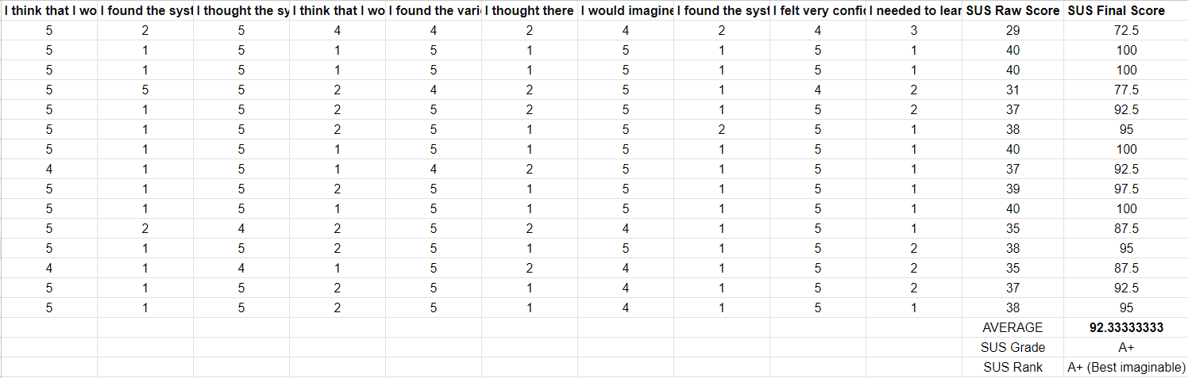
Figure 22. SUS Computation for Mobile
After the computation of the SUS scores for Mobile for Students, the results are interpreted to provide insights into the overall usability, user experience, and potential areas for improvement of the system. The interpretation presented is based on the analysis described on page 19, reflecting the researchers’ assessment of how effectively the mobile application meets the needs of its intended users.
Table 2. Interpretation of SUS result for Mobile
Overall SUS Score |  | Grade |  | Adjective | Acceptable
92.33 |  | A+ |  | Best Imaginable | Acceptable
The researchers conclude that the developed Lorma Access+ Mobile Application for students is highly usable. The system achieved an overall SUS score of 92.33 (See Figure 18), corresponding to an A+ grade and a “Best Imaginable” adjective rating. This high score reflects that students were able to access their academic records, navigate the application, and perform essential tasks with ease and confidence.
The “Best Imaginable” rating shows that the mobile application not only meets the basic needs of students but also provides a smooth and satisfying user experience. Users found it easy to navigate, understand, and use the features without much effort. This result indicates that the application is well-designed, and functional, making it a reliable tool for students to access their academic records. Overall, the mobile application is highly effective in fulfilling the requirements of its intended audience, and the positive feedback provides strong validation for its deployment and potential adoption as a standard tool for students.
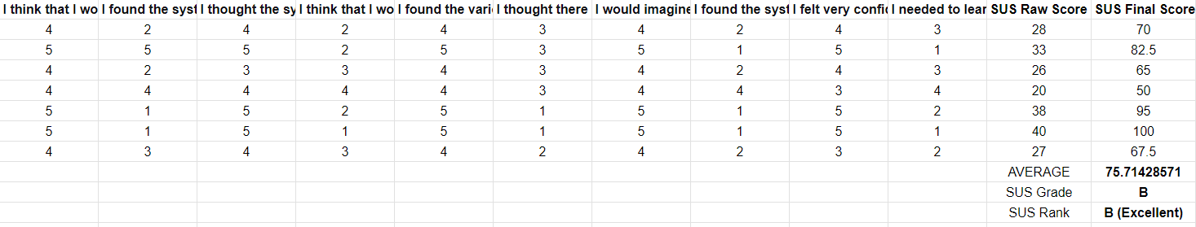
Figure 23. SUS Computation for Web
After computing the System Usability Scale (SUS) scores for the web interface designed for faculty members, the interpretation of the results is presented below, based on the analysis described on page 19. These findings provide insights into the overall usability of the system, the user experience from the faculty’s perspective, and identify specific areas where improvements can be made to enhance efficiency, accessibility, and satisfaction in using the platform.
Table 3. Interpretation of SUS result for Mobile
Overall SUS Score |  | Grade |  | Adjective | Acceptable
75.71 |  | B |  | Good | Acceptable
The researchers conclude that the developed Lorma Access+ Web Application for faculty is highly usable. The system achieved an overall SUS score of 75.71, corresponding to a B grade and a “Good” adjective rating, indicating that faculty users found the application generally easy to use, functional, and efficient for performing their tasks.
The “Good” rating indicates that faculty members were able to navigate the system, retrieve scores from Google Classroom, and compute grades with relative ease, although minor areas for improvement remain to further enhance usability. Overall, the web application effectively supports faculty in managing academic tasks, streamlines grading processes, and improves efficiency, while providing a positive user experience that aligns with the needs of its intended users.

CHAPTER IV
CONCLUSIONS AND RECOMMENDATIONS
This chapter presents the findings of the study and provides recommendations based on the results and insights gained throughout the research.
Conclusions
For the first objective, the study established that faculty members currently rely on spreadsheets and manual encoding to manage student grades. Key practices include ensuring accuracy, maintaining confidentiality, and adhering to institutional deadlines. However, the lack of an automated system causes delays, especially during grading periods. The research highlighted the need for a standardized and streamlined procedure to enhance efficiency and reduce errors in grade management.
For the second objective, the mobile version of Lorma Access SIS addressed the limitations of the web-only platform, providing students with convenient, on-the-go access to their academic records. The researchers concluded that the mobile application significantly enhances the student user experience by improving accessibility, navigation, and usability, allowing students to efficiently monitor grades, schedules, and financial records.
For the third objective, the researchers developed a system that allows faculty members to connect their Google Classroom accounts and import students’ raw scores with minimal effort. The web application applies the institution’s grading matrix to compute term grades and final ratings. The researchers concluded that the web application effectively supports faculty in automating the grading process and improving productivity.
For the fourth objective, the overall result shows that both the mobile application for students and the web application for faculty were successfully evaluated using the System Usability Scale (SUS). For the mobile application, the evaluation yielded an overall SUS score of 92.33, which corresponds to an A+ grade and a “Best Imaginable” adjective rating. This result indicates exceptional usability and reflects that students were able to navigate the interface, access academic records, and execute key tasks with ease and confidence. For the web application, the SUS evaluation produced an overall score of 75.71, which corresponds to a B grade and a “Good” adjective rating. This score signifies that faculty members found the system generally efficient, functional, and easy to operate, particularly in managing classroom activities, retrieving Google Classroom data, and computing grades.
Recommendations
The researchers offer the following suggestions for this study:
- Enhance the grading automation features of the web application
- Expand mobile application functionalities for students.
- Expand the mobile application to support iOS devices.
- Extend the web application to include grade publishing

References
Published
Alenezi, M. (2023). Digital learning and digital institution in higher education. Education Sciences, 13(1). https://doi.org/10.3390/educsci13010088
Ali, A. A. A., & Dauwed, M. (2022). Development of a hybrid mobile app for student management system. Journal of Advanced Sciences and Nanotechnology. https://www.researchgate.net/publication/361716658_Development_of_A_Hybrid_Mobile_App_for_Student_Management_System
Alfalah, A. (2023). Factors influencing students’ adoption and use of mobile learning management systems (m-LMSs): A quantitative study of Saudi Arabia. International Journal of Information Management Data Insights, 3(1). https://www.sciencedirect.com/science/article/pii/S2667096822000866
Barrot, J. S., Llenares, I. I., & del Rosario, L. S. (2021). Students’ online learning challenges during the pandemic and how they cope with them: The case of the Philippines. Education and Information Technologies, 26(6), 7321–7338. https://doi.org/10.1007/s10639-021-10589-x
Hassan, A., & Andebe, N., Nyambo, G., Kaijage, S. (2022). Integrating Mobile Computing in University Information Management Systems to Improve Access and User Experience. Indian Journal of Science and Technology. https://indjst.org/articles/integrating-mobile-computing-in-university-information-management-systems-to-improve-access-and-user-experience
Naik, S. (2024). Barriers to the Adoption of E-Learning in Higher Education Institutes (HEI). International Journal of E-Services and Mobile Applications. https://www.sciencedirect.com/org/science/article/pii/S1941627X24000029
Naveed, Q. N., Choudhary, H., Ahmad, N., Alqahtani, J., & Qahmash, A. I. (2023). Mobile learning in higher education: A systematic literature review. Sustainability, 15(18). https://doi.org/10.3390/su151813566
Online Resources
Annor, P.S., Kayang, E.P., Boateng, S., & Boateng, G. (2021). AutoGrad: Automated Grading Software for Mobile Game Assignments in SuaCode Courses. https://arxiv.org/pdf/2107.12244
Annapureddy, H. (2023). Student grade management system. https://www.linkedin.com/pulse/student-grade-management-system-hiranmai-annapureddy
B., J. (2024). 10 top APIs for learning management systems. Stream. https://getstream.io/blog/10-top-apis-for-learning-management-systems/
Corecampus. (2023). How APIs work with an SIS. Campus Cafe. https://corecampus.com/how-apis-work-with-an-sis-integrations/
Comunetti. (2025). Mobile-First Student Engagement in Higher Education - Raftr. https://www.raftr.com/mobile-first-student-engagement-in-higher-education/
Davis, A. (2024). How to approach legacy application integration. OpenLegacy. https://www.openlegacy.com/blog/legacy-application-integration
DiMaria, J. (2024). Automatic grading systems: Every teacher's biggest time saver. Digiexam. https://www.digiexam.com/blog/automatic-grading-system-benefits-education
Han, E. (2022). What is Design Thinking & why is it important?. Harvard Business School. https://online.hbs.edu/blog/post/what-is-design-thinking
Hsing, C. (2020). Improve student success and increase teacher time with autograding. https://github.blog/developer-skills/github-education/improve-student-success-and-increase-teacher-time-with-autograding/
Hurter, B. (2024). How a student information system enhances educational efficiency. Element451 Higher Ed CRM. https://element451.com/blog/how-student-information-system-enhances-education
Kumar, A. (2025). Revolutionizing education with API-driven digital integration and automation. Analytics Insight. https://www.analyticsinsight.net/automation/revolutionizing-education-with-api-driven-digital-integration-and-automation
Nikolopoulou, K. (2022). What is purposive sampling? Scribbr. https://www.scribbr.com/methodology/purposive-sampling/
Oliveira, D., Pedro, L., & Santos, C. (2021). The Use of Mobile Applications in Higher Education Classrooms: An Exploratory Measuring Approach in the University of Aveiro. https://files.eric.ed.gov/fulltext/EJ1314744.pdf
OptoFidelity. (2021, August 25). Grading automation saves money and improves customer satisfaction. https://www.optofidelity.com/insights/blogs/automated-grading-saves-money-and-improves-customer-satisfaction
Penfold, S. (2016). 5 Steps To Convert Legacy eLearning Into Modern, Mobile-Friendly Learning. eLearning Industry. https://elearningindustry.com/5-steps-convert-legacy-elearning-modern-mobile-friendly-learning
SCRUMStudy. (2024). How does Agile Scrum methodology support iterative development and continuous improvement? https://www.scrumstudy.com/article/iterative-

Wissen. (2023). Bridging Education and Technology: Revolutionizing Student Engagement. https://www.wissen.com/insights/success-stories/case-study-app-for-students-to-know-details-on-the-go
Wood, H. (2021). Level up your student information system (SIS): Moving processes from manual to automated. Collegis Education. https://collegiseducation.com/insights/level-up-student-information-system/
Zhang, S. (2022). The long-term effects of automatic grade promotion on child development. SSRN. https://papers.ssrn.com/sol3/papers.cfm?abstract_id=4021998
Bhargava, M., Gandhi, M. A., Qayumi, E., Phelps, V., Zhuang, Z., Nathan, N., Bernard, C., & Garcia, D. (2025, March 1). GradeSync: A tool for automating incomplete processing to support mastery learning (SIGCSE TS 2025 - Posters). SIGCSE TS 2025. https://sigcse2025.sigcse.org/details/sigcse-ts-2025-posters/53/GradeSync-a-Tool-for-Automating-Incomplete-Processing-to-Support-Mastery-Learning

Appendix A
Pre-development Interview Letter
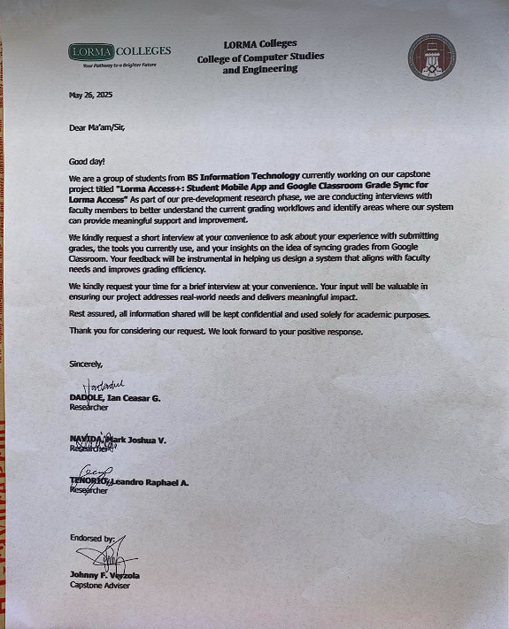
Appendix B
Pre-development Survey Questionnaires
For Students
- How often do you access the student portal? → What device do you usually use?
- What’s the most difficult task to do on the system? → Can you walk me through your last experience doing it?
- Have you missed any deadlines because of system issues? → What happened and how did you find out?
- How do you usually check your grades? → Do you rely more on Google Classroom or the portal? Why?
- Is it easy to understand your academic standing or progress? → What do you wish it showed better?
- Do you use the system on your phone? → If not, why?
- What feature do you wish the portal had? → How would it help you?

For Faculty
- Describe your process for submitting grades. → How long does it usually take per class?
- Do you use any tools (e.g., spreadsheets) to compute final grades? → Why not enter directly into the system?
- Have you experienced errors while copying grades? → What do you do when that happens?
- Do you feel confident that the system reflects accurate grades? → What makes you feel that way?
- Would you be open to syncing grades directly from Google Classroom? → What concerns would you have?
- Do you receive training or support on using the system? → What kind of help would improve your experience?
- How do you handle grade disputes with students? → Does the system help in resolving them?
For System Admins
- What are the most common support requests you receive? → Which ones take the most time to resolve?
- How are grades entered and verified across terms? → What part of that process causes delays?
- Are there any data accuracy or syncing issues with Google Classroom? → How are those handled?
- Do you track who made changes in the system? → How is that information used?
- If you could upgrade one part of the system, what would it be? → Why that part?
- Is it possible to create an independent API that connects to your database, functions as a server for a mobile client, and fetches Google Classroom data using Google’s API? → What limitations or risks do you foresee in setting this up?

Appendix C
SUS Survey Questionnaires 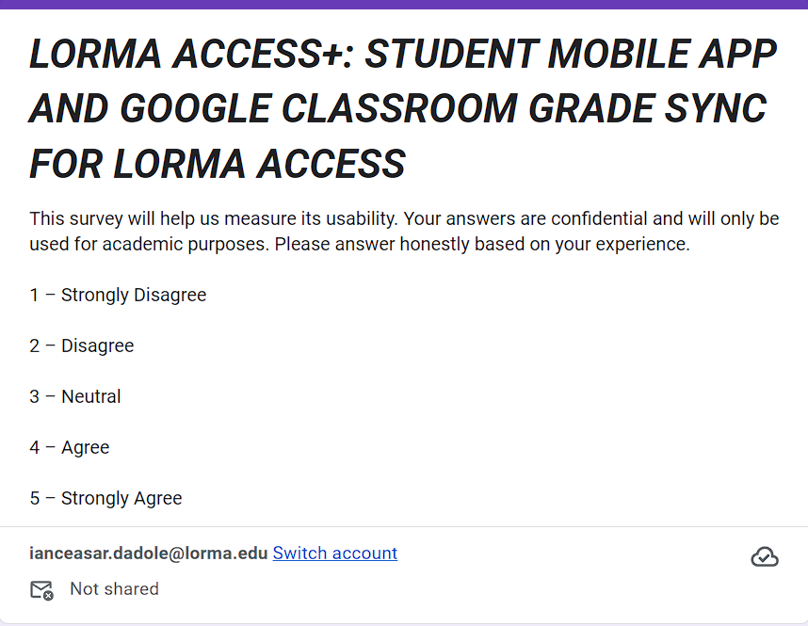

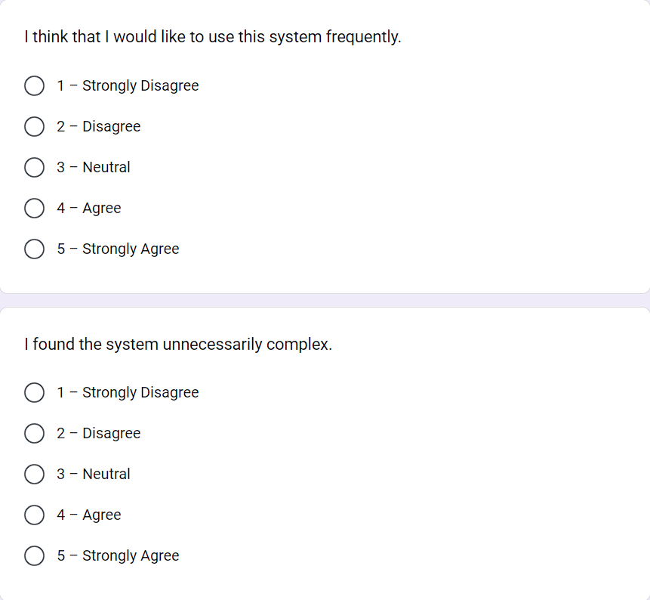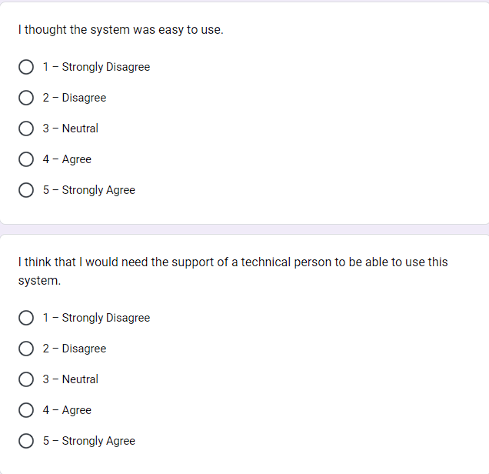
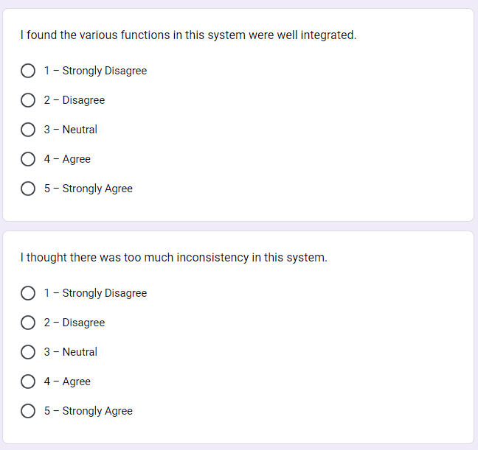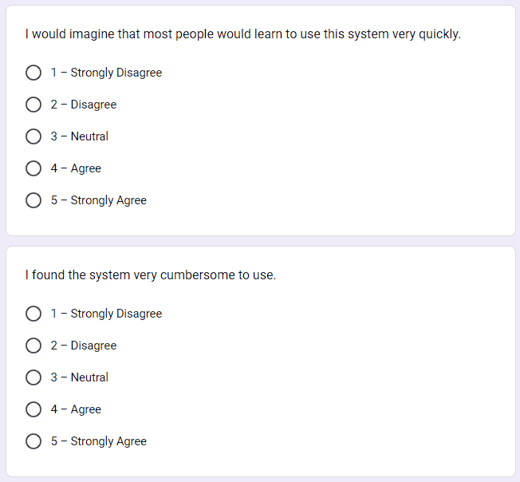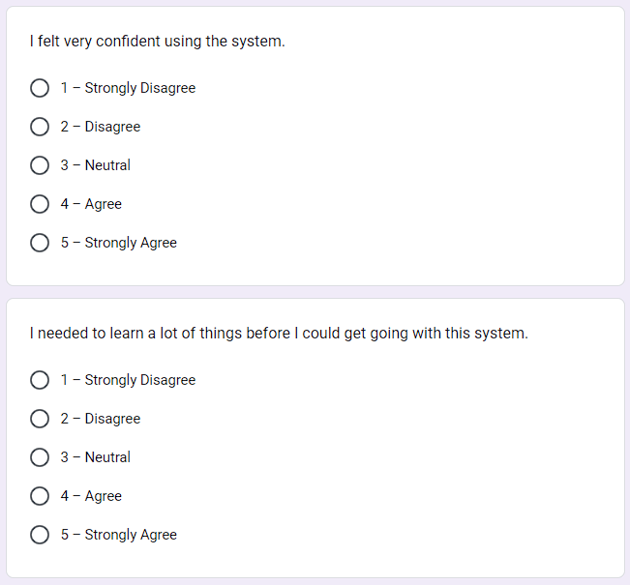
APPENDIX D
Transcript of the System Usability Scale (SUS) Survey for Mobile
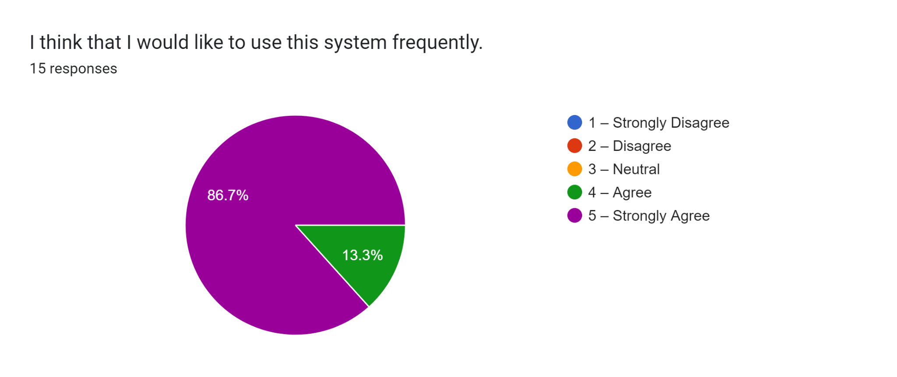
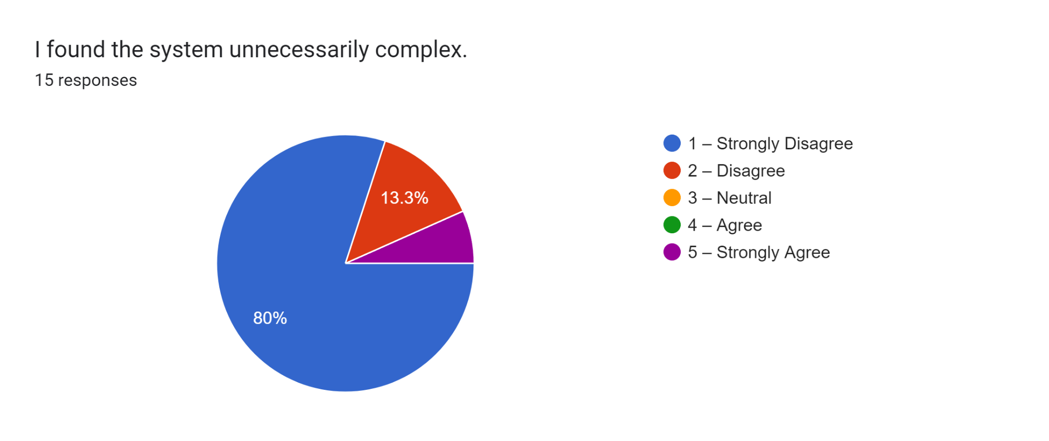
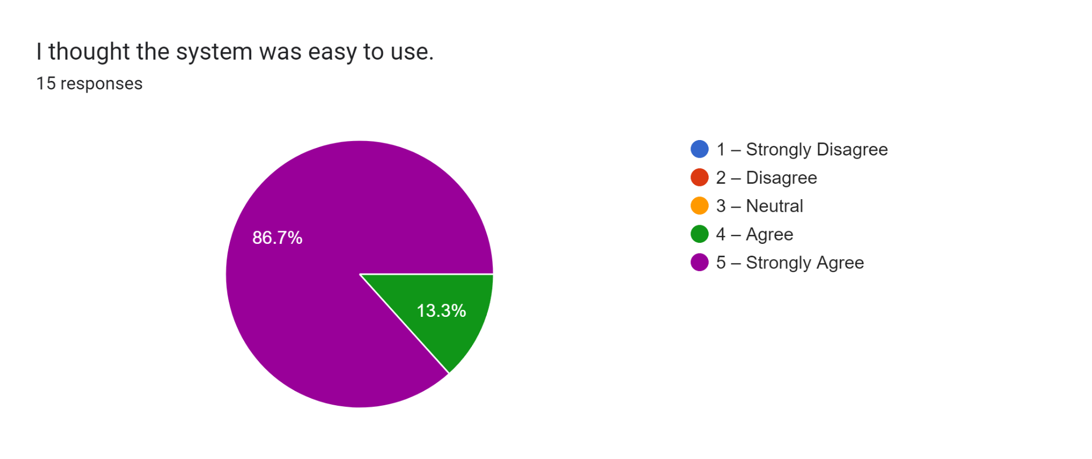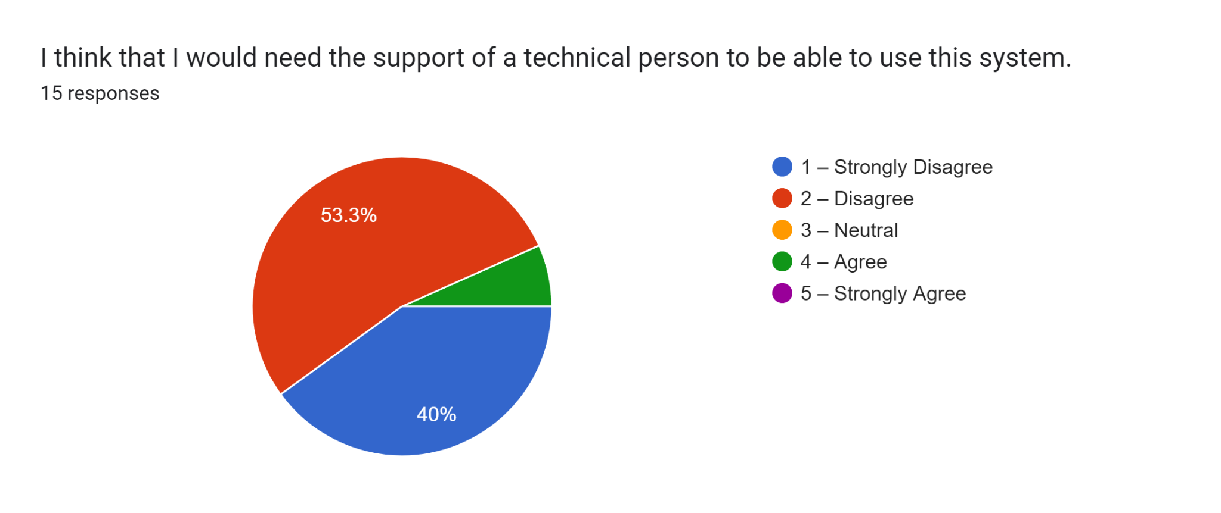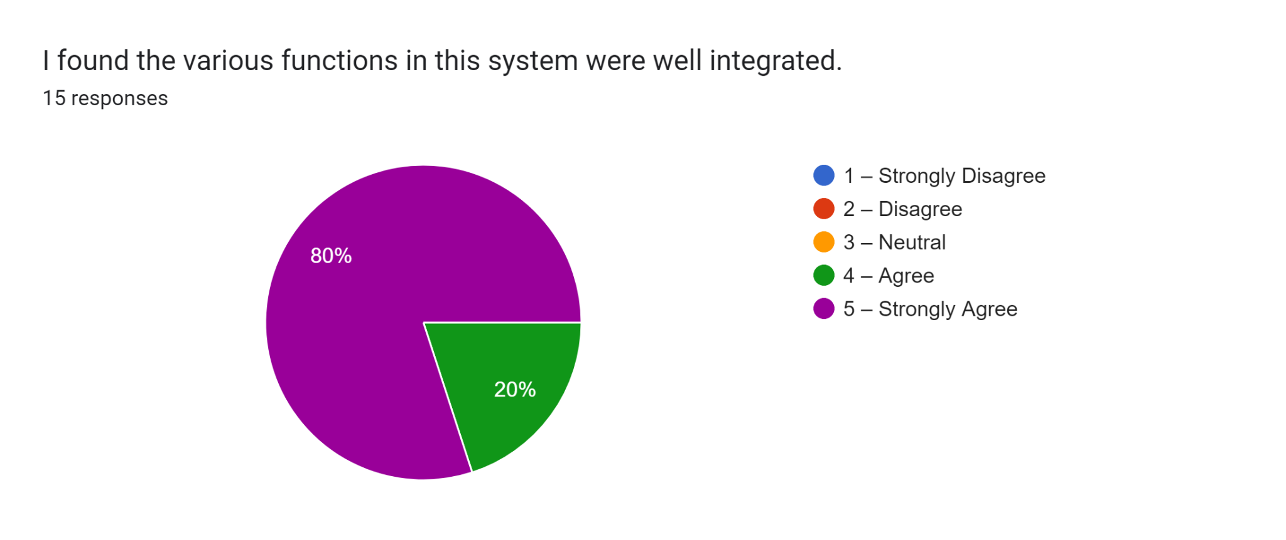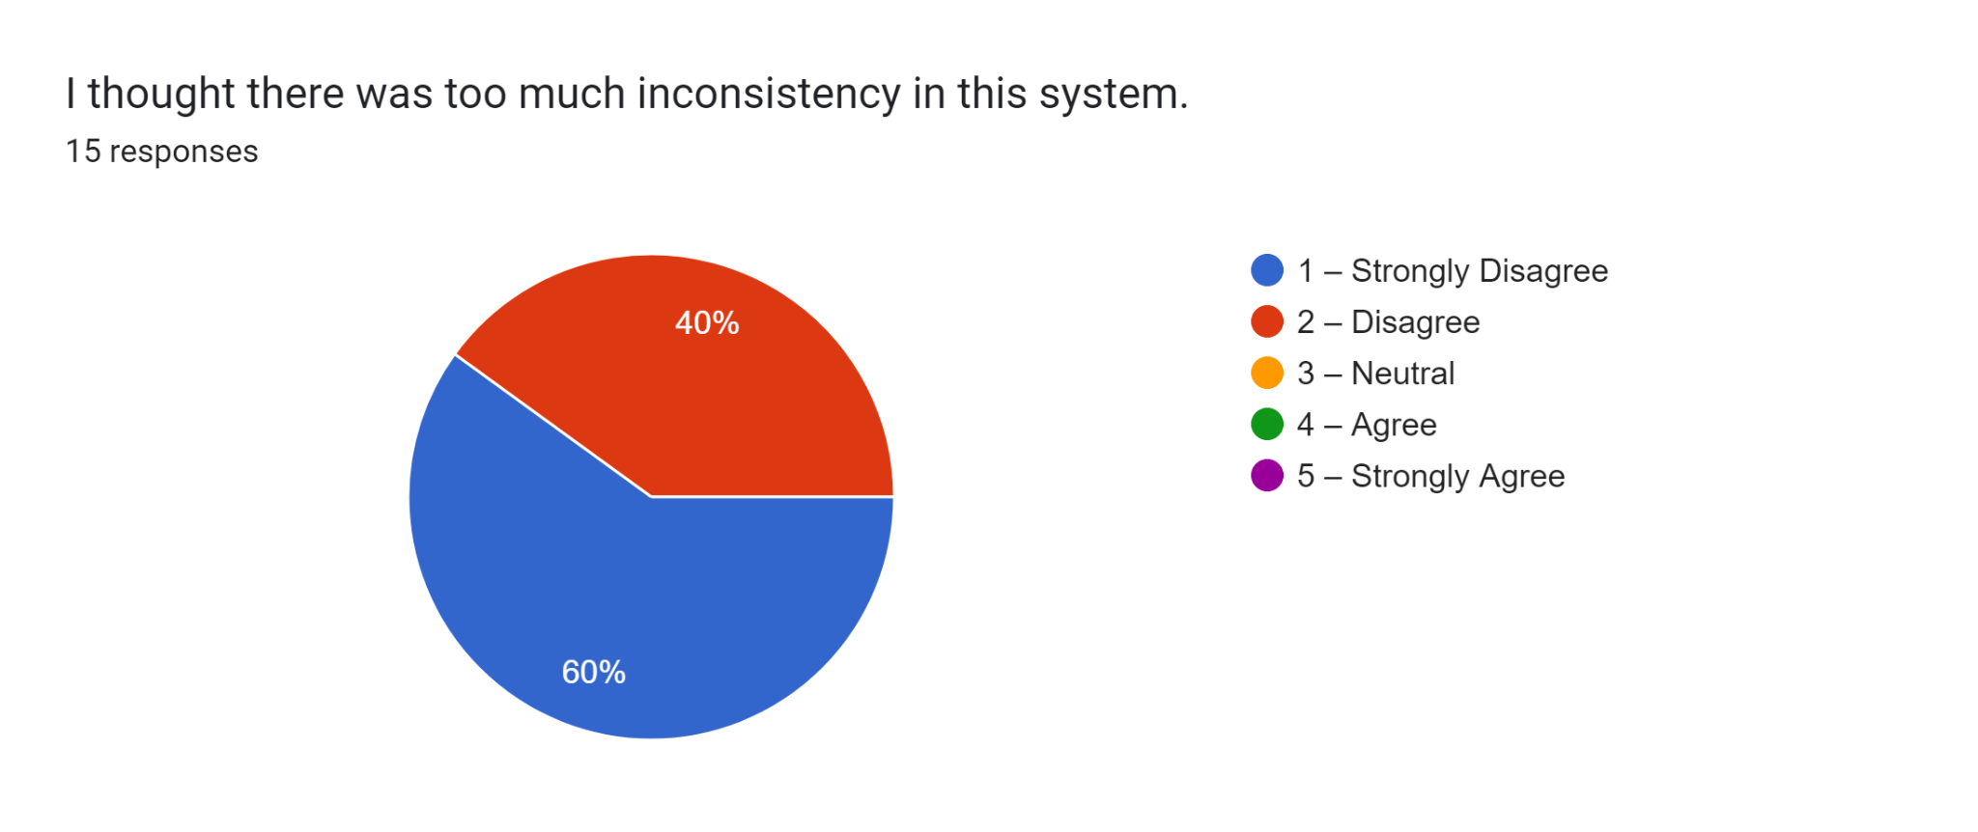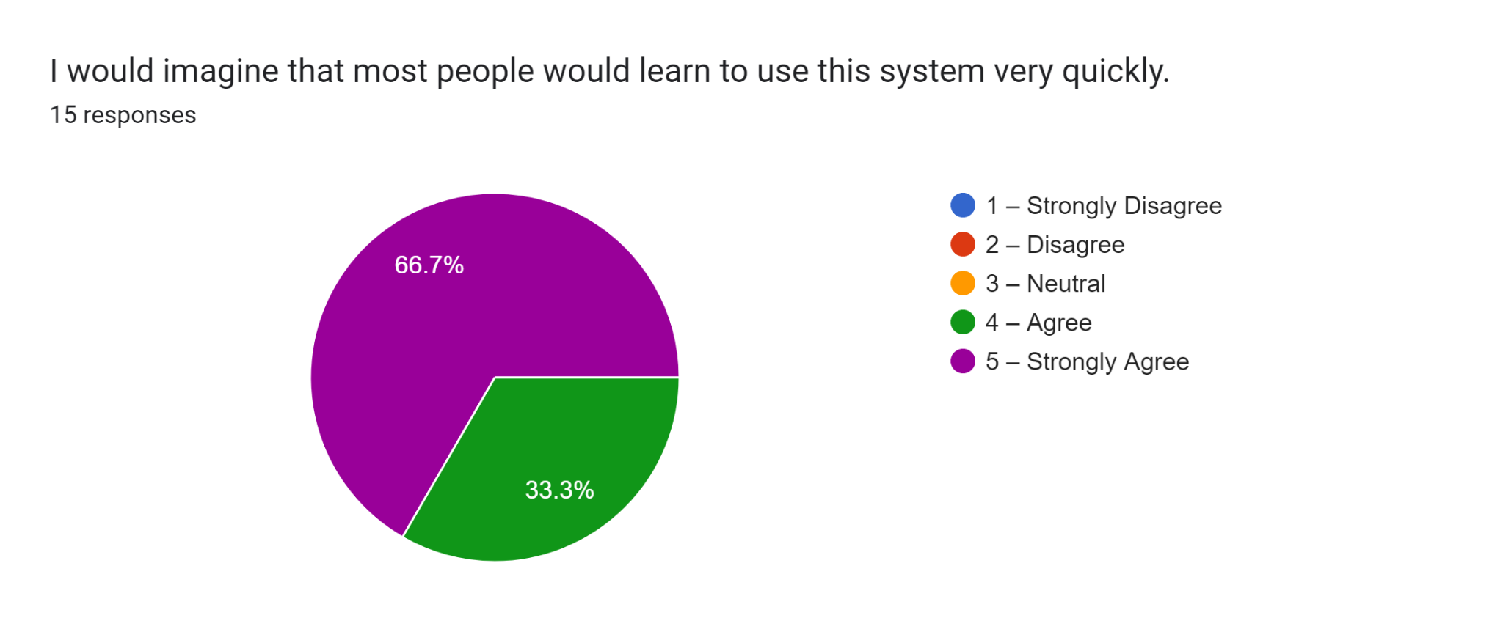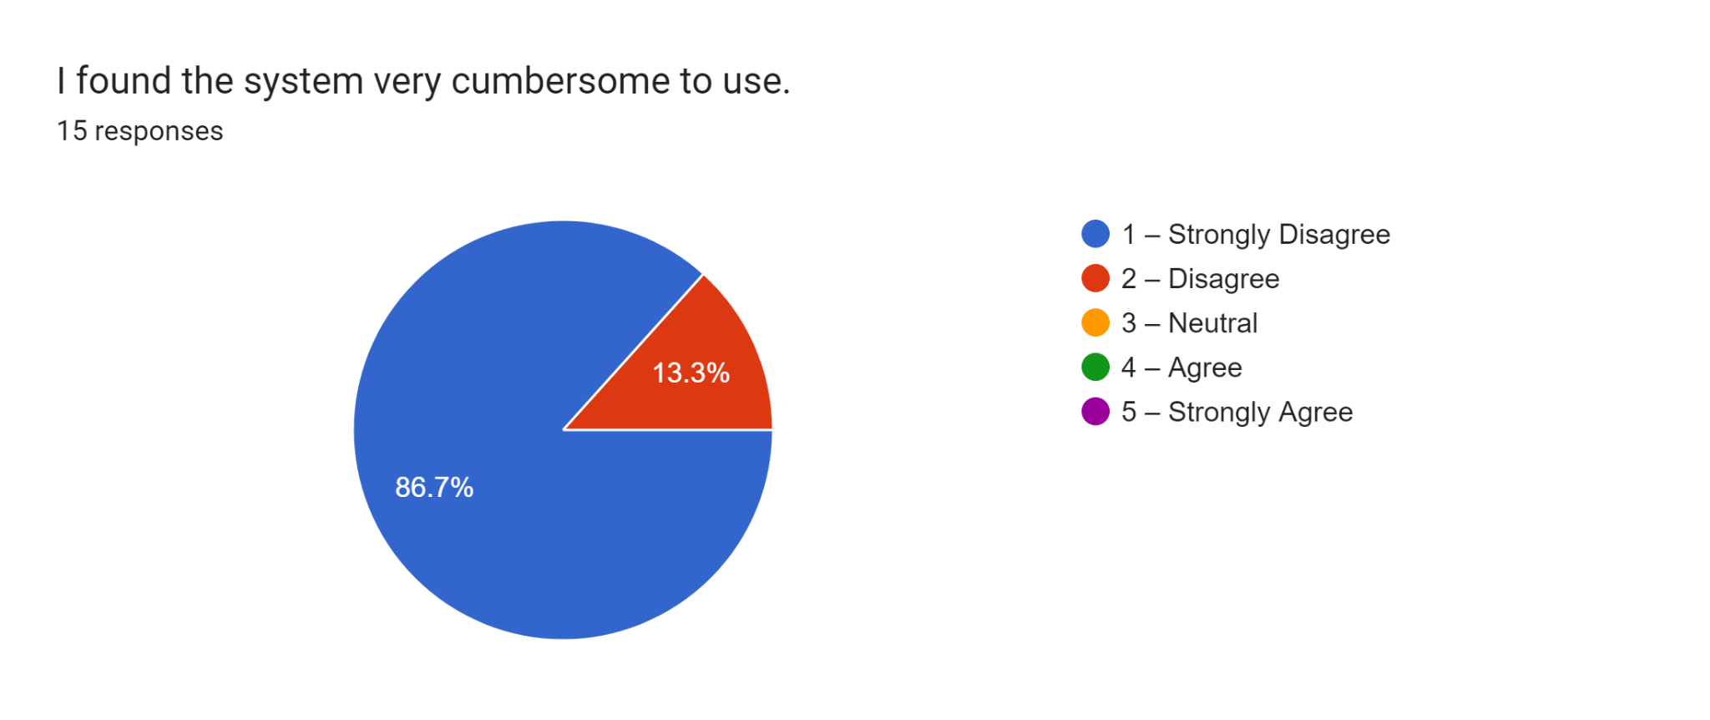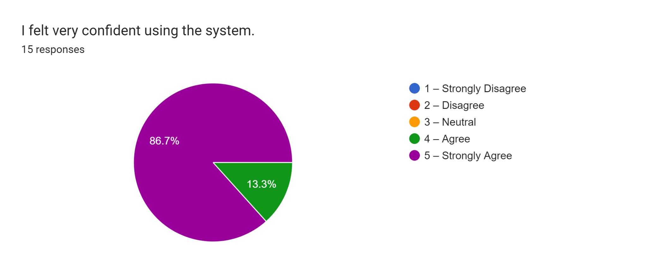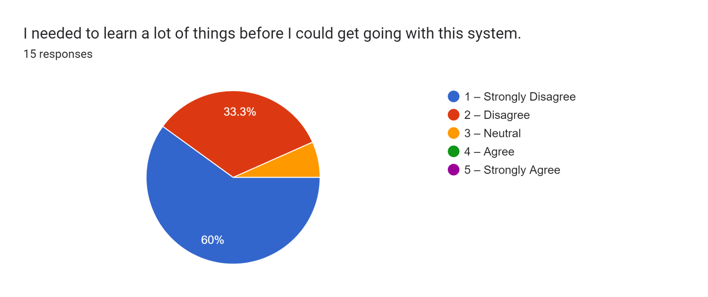

APPENDIX E
Transcript of the System Usability Scale (SUS) Survey for Web
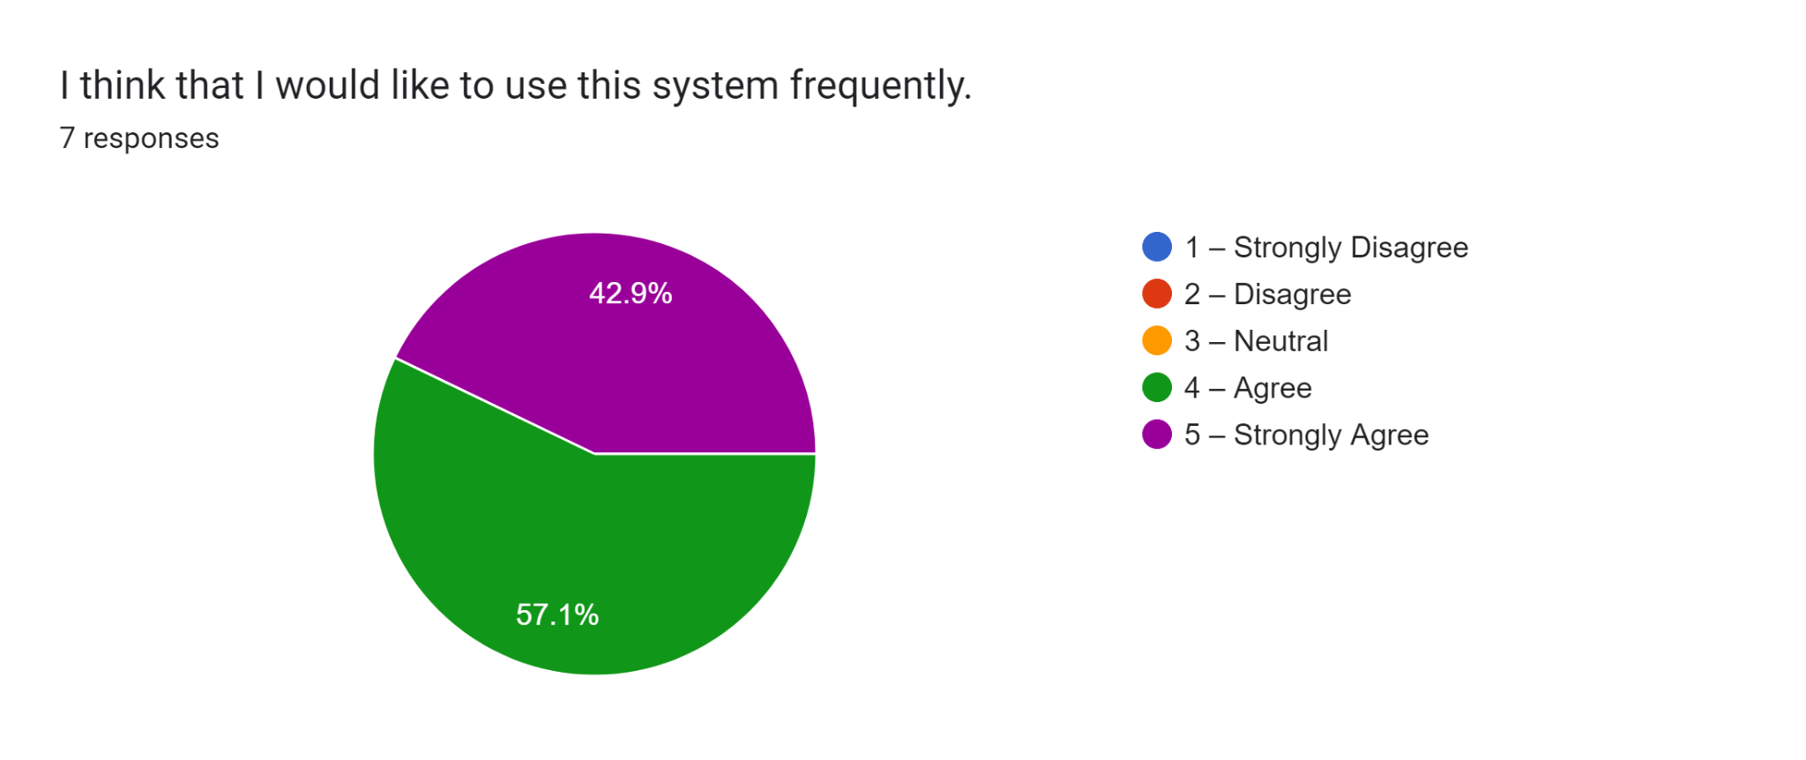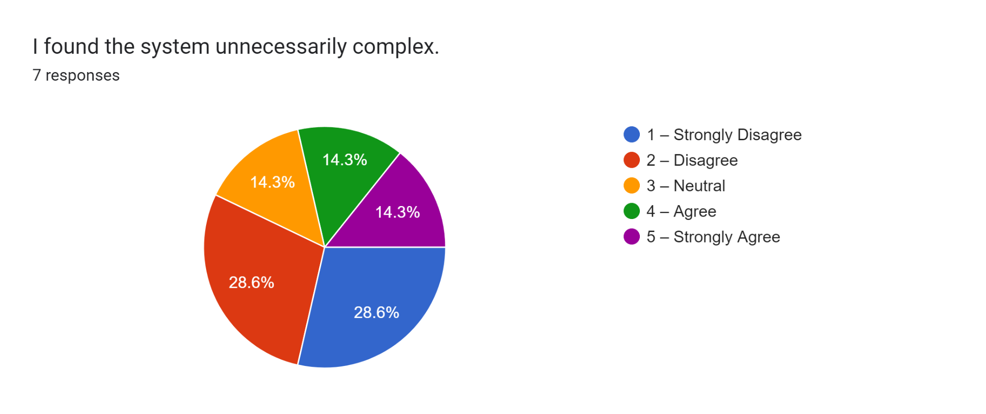
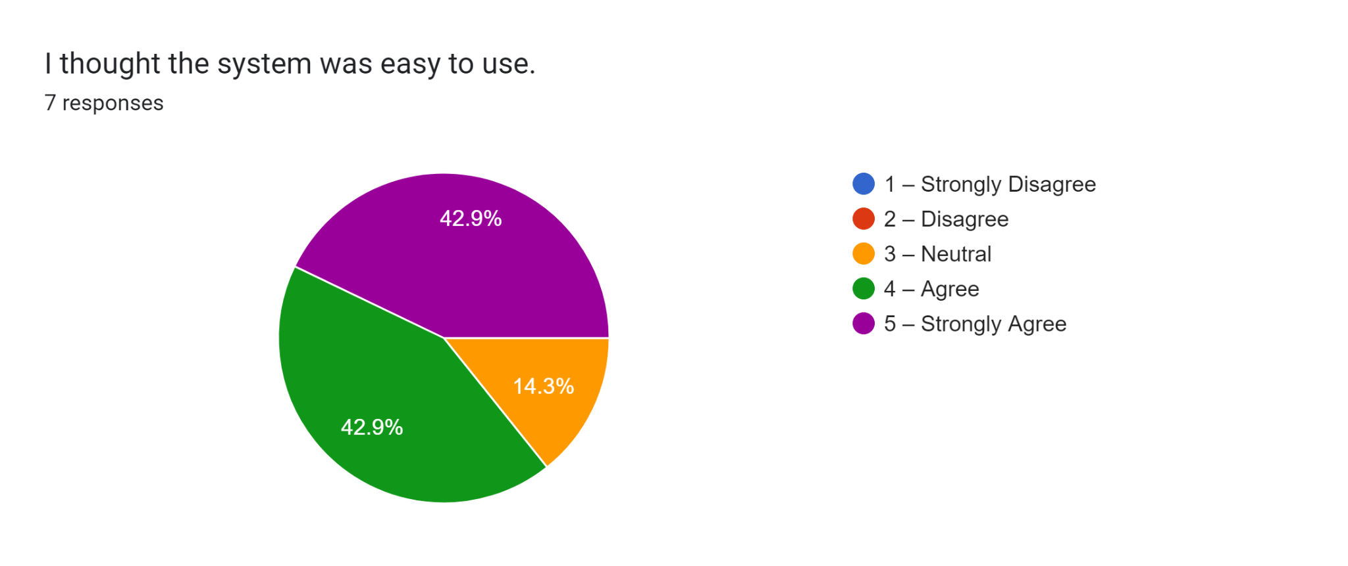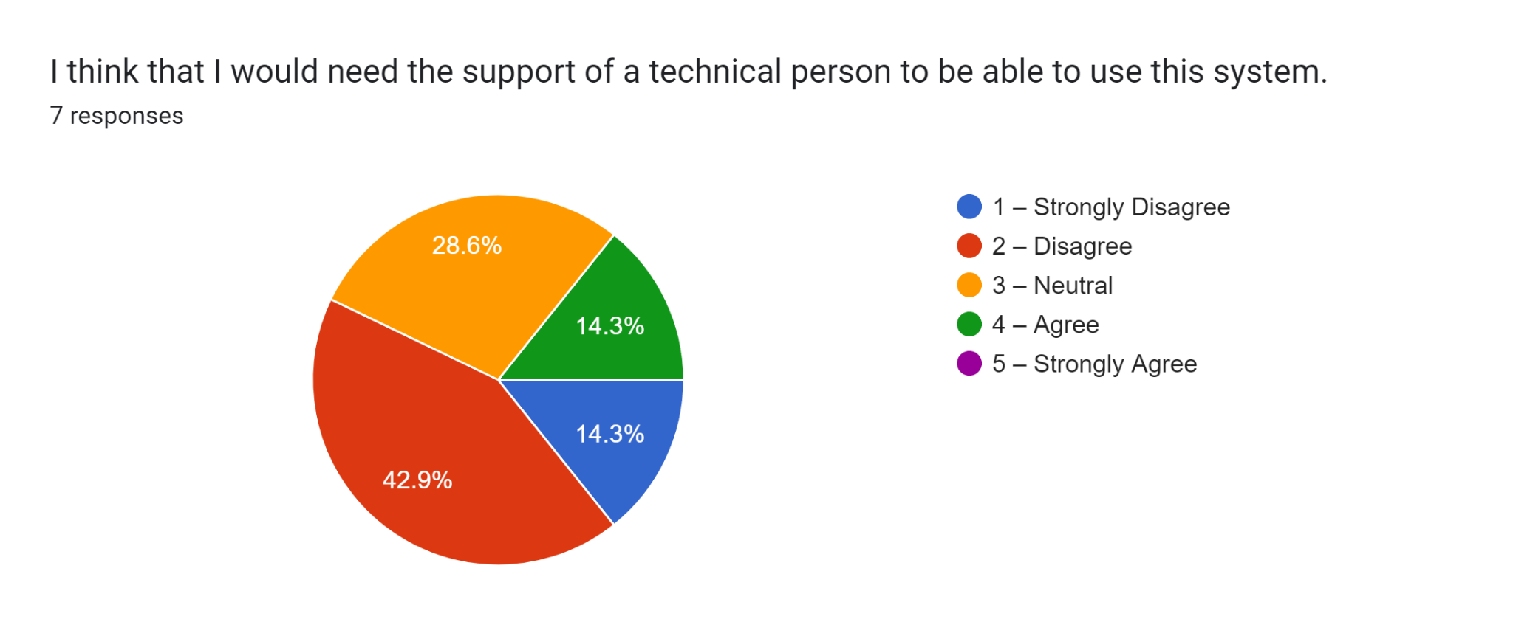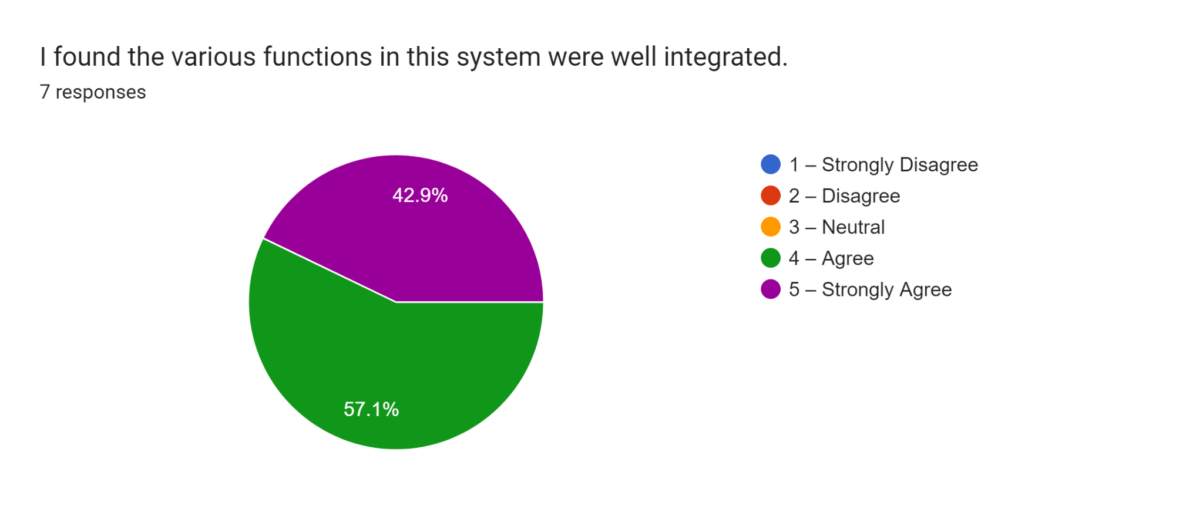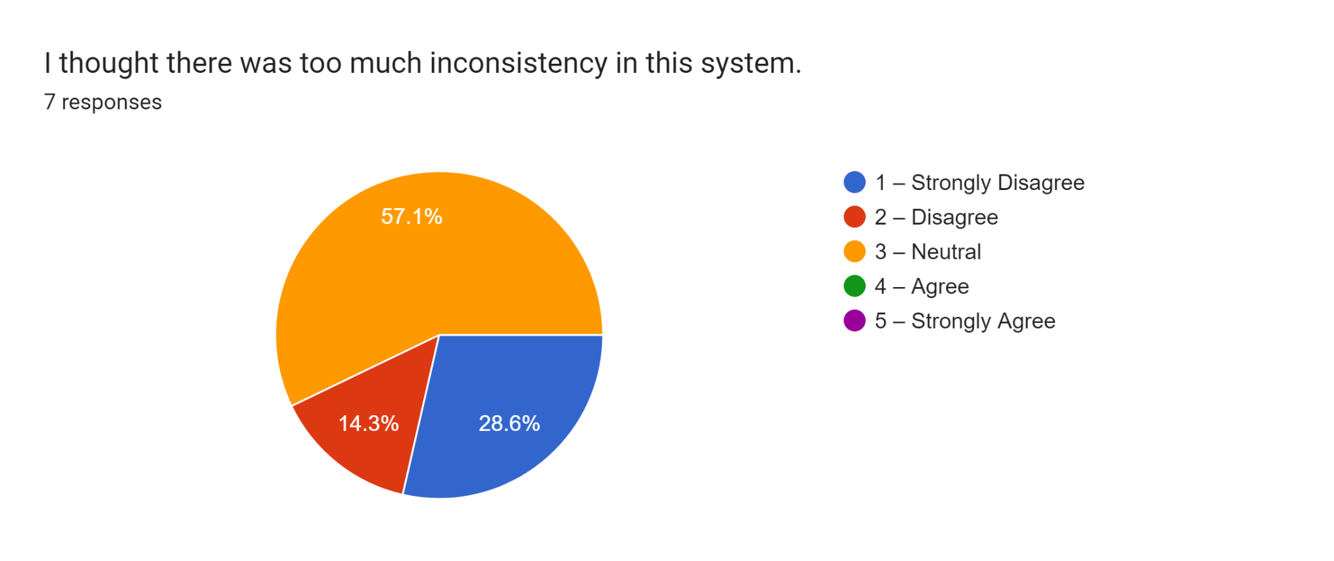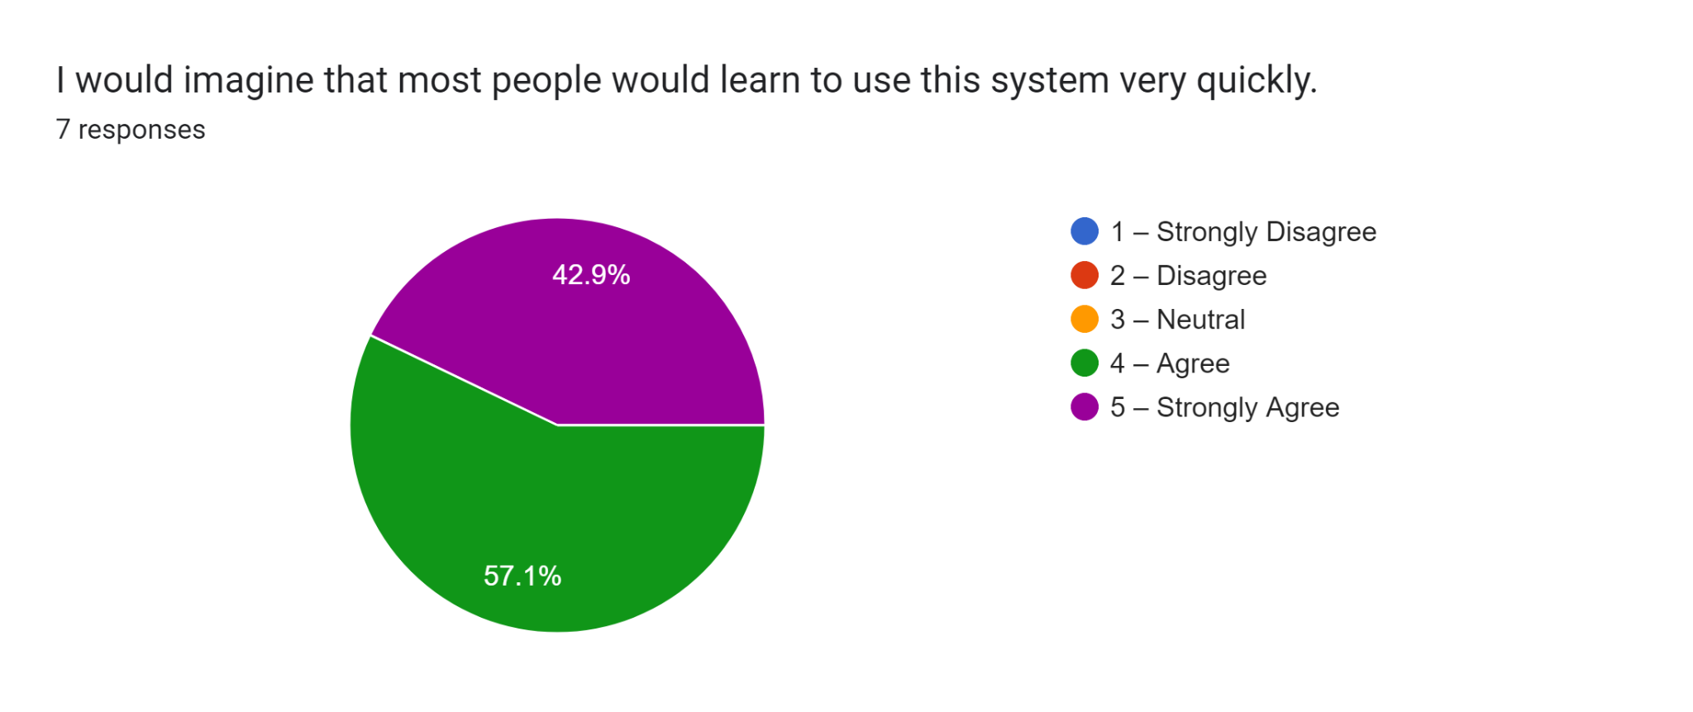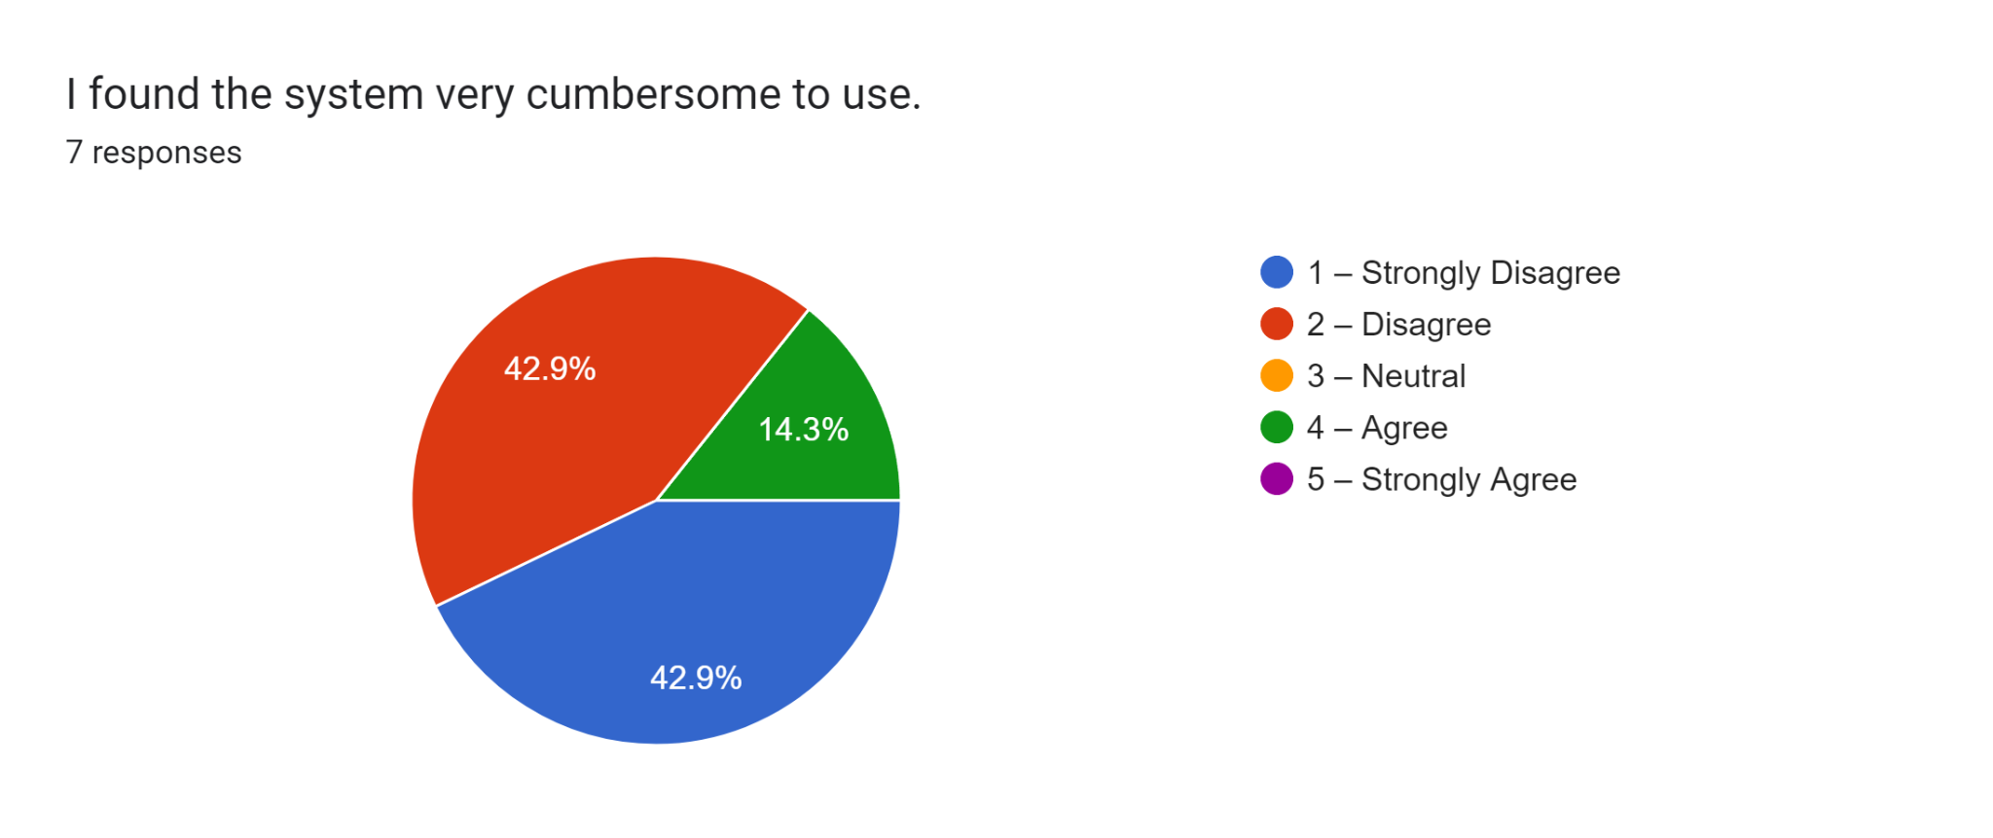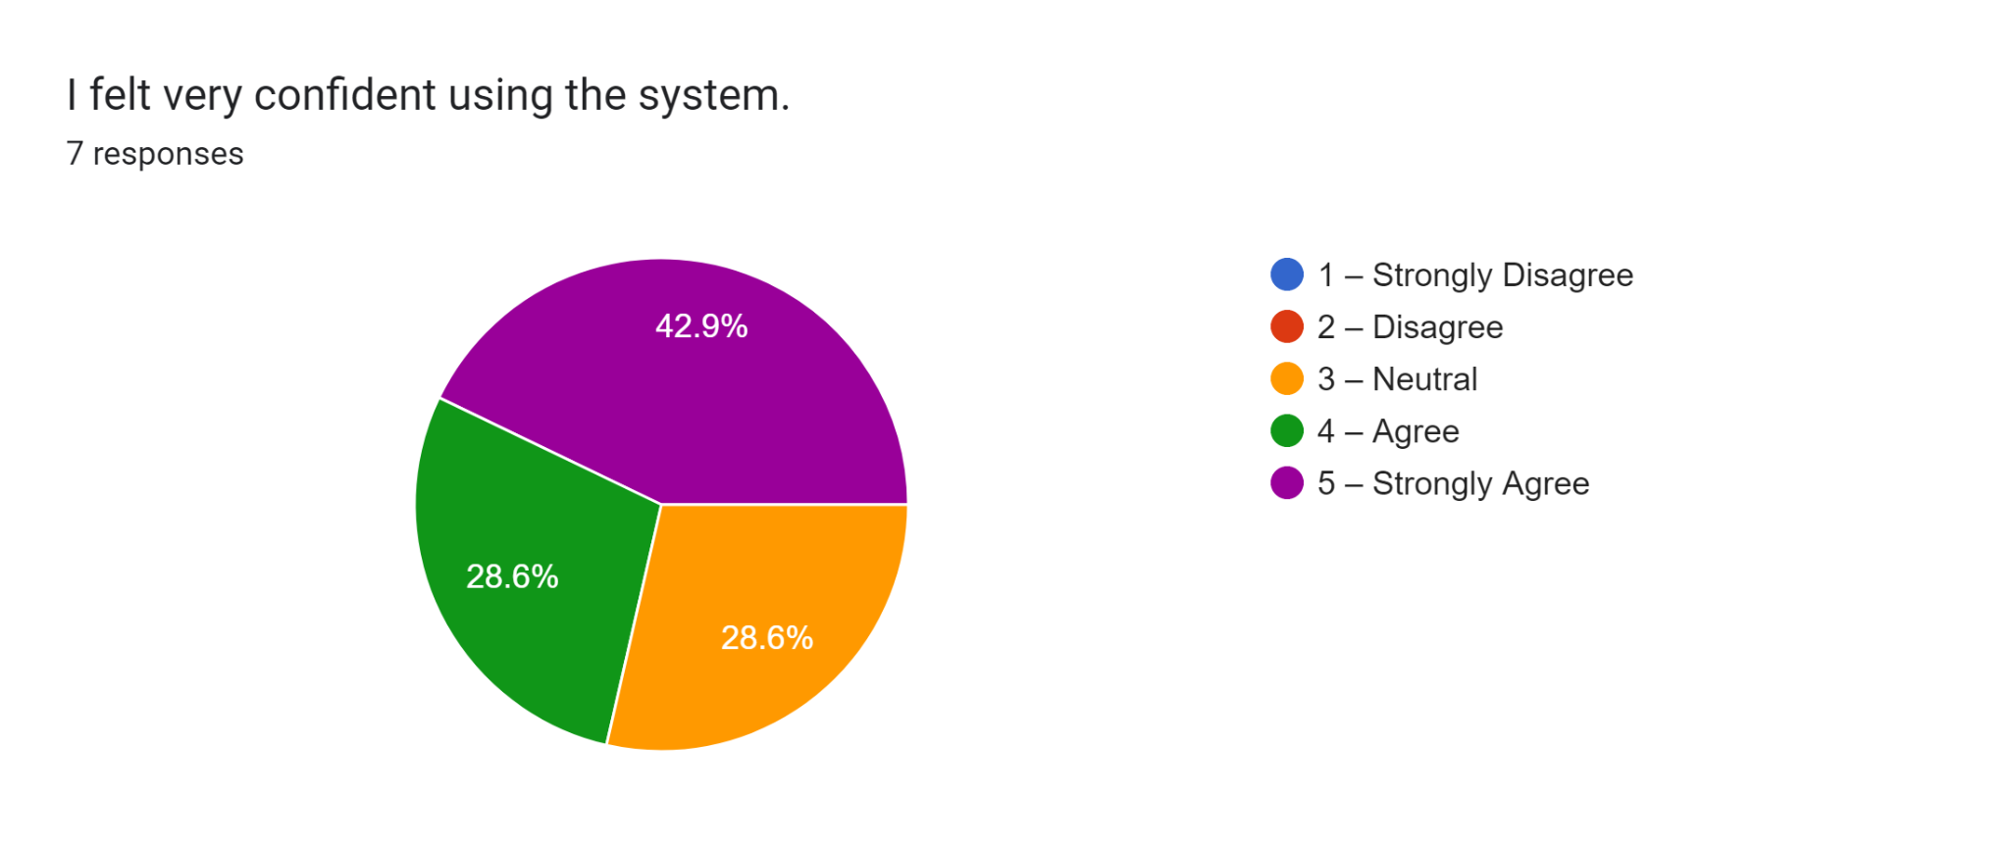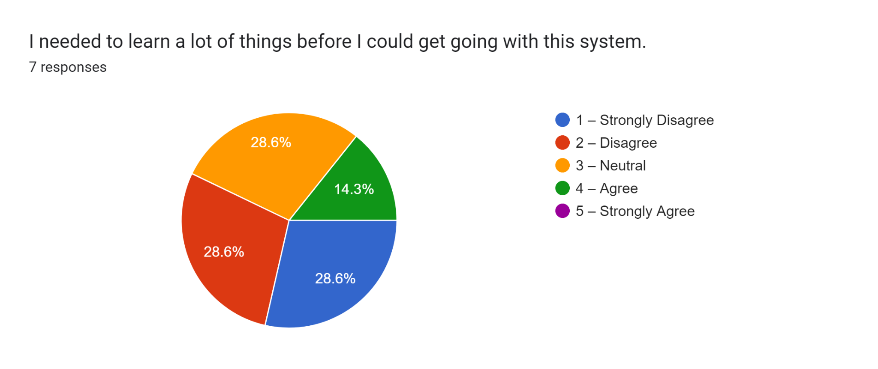


Curriculum Vitae

IAN CEASAR GURTIZA DADOLE
I. PERSONAL INFORMATION
Address : Suguidan Norte, Naguilian, La Union
Contact Number : 09563921203
Email add : ianceasar.dadole@lorma.edu
Date of Birth : October 28, 2004
Place of Birth : San Fernando City, La Union
II. EDUCATIONAL BACKGROUND
• Tertiary Education
• Lorma Colleges | 2022 – Present
Bachelor Science of Information Technology (Undergraduate)
• Secondary Education
- Senior High School
Naguilian National High School Senior High School | 2020-2022
Science Technology Engineering and Mathematics (STEM)
- Junior High School
Naguilian National High School | 2016-2020
- Primary Education
Naguilian Central School | 2010-2011
Dr. Hermogenes F. Belen Elementary School | 2011-2016
III. AWARDS/CITATIONS/RECOGNITIONS RECEIVED
- Half Scholar and Dean’s Lister | 2022-2025 (Lorma Colleges)
- With Honors | Grade 8-12 (Naguilian National High School)
- With Honors | Grade 3 (Dr. Hermogenes F. Belen Elementary School)
- Conduct Awardee | Grade 7 (Naguilian National High School)
IV. WORK EXPERIENCE : N/A
V. ELIGIBILITY : N/A

VI. SEMINARS ATTENDED
- LEAD IT: Leadership and Empowerment through Ambassadorship in Digital Innovation for IT Webinar
- NCCEB (National Conference on Computing, Education, and Business)
- 2024 DICT Regional Road Show
- Global Conference on Robotics and Artificial Intelligence Technologies
- AI in Focus: Seminar with Woosong University
- DevFest Baguio 2025
VII. INVOLVEMENT IN RESEARCH/RESEARCHES CONDUCTED
- Capstone 1: LORMA ACCESS+: MOBILE ACCESS AND AUTOMATED GRADE SYNC FROM GOOGLE CLASSROOM TO LORMA COLLEGES STUDENT INFORMATION SYSTEM
- Practical Research: IMPROVISED PORTABLE POWER BANK USING USED BATTERIES OF LAPTOPS
- Gender and Society: EQUALITY IN EDUCATION: ANALYZING THE BENEFITS OF GENDER-NEUTRAL UNIFORMS TO LORMA’S HIGHSCHOOL STUDENTS


Curriculum Vitae

Leandro Raphael Aragon Tenorio
I. PERSONAL INFORMATION
Address : Oaqui #3, Luna, La Union
Contact Number : 09612622873
Email add : leandroraphael.tenorio@lorma.edu
Date of Birth : November 04, 2000
Place of Birth : Balaoan, La Union
II. EDUCATIONAL BACKGROUND
• Tertiary Education
- Lorma Colleges | 2023 – Present
- Ama Computer College - 2019-2021
- Bachelor Science of Information Technology (Undergraduate)
• Secondary Education
• Senior High School
Lyceum Northwestern University/Francisco Q. Duque Medical Foundation | 2017-2019
• Junior High School
Lyceum Northwestern University/Francisco Q. Duque Medical Foundation | 2013-2017
• Primary Education
Carthel Science Educational Foundation INC. | 2007-2013
III. AWARDS/CITATIONS/RECOGNITIONS RECEIVED
- Participation/Recognition For National Book Week Activities.
- Dean’s Lister | Second Trimester, 2020-2021 (AMA Computer College - San Fernando La Union Inc.).
- With Honors | Grade 7 (Lyceum Northwestern University/FQDMF).
- With Honors | Grade 1 - 6 (Carthel Science Educational Foundation INC.).
- Chess Varsity | Grade 11 (Lyceum Northwestern University/FQDMF).
IV. WORK EXPERIENCE :
- OJT | Mr. Robot, Arellano st. Dagupan City, Pangasinan.
V. ELIGIBILITY : N/A
VI. SEMINARS ATTENDED
- Global Conference on Robotics and Artificial Intelligence Technologies
- AI in Focus: Seminar with Woosong University
- 3rd ICT Congress : Vlogging | Senior HighSchool (LNU/FQDMF)
- 3rd ICT Congress : Cyber Security| Senior HighSchool (LNU/FQDMF)
- 3rd ICT Congress : Internet of Things| Senior HighSchool (LNU/FQDMF)
VII. INVOLVEMENT IN RESEARCH/RESEARCHES CONDUCTED
- Capstone 1: LORMA ACCESS+: MOBILE ACCESS AND AUTOMATED GRADE SYNC FROM GOOGLE CLASSROOM TO LORMA COLLEGES STUDENT INFORMATION SYSTEM

CURRICULUM VITAE

Mark Joshua Valdez Navida

I. PERSONAL INFORMATION
Address : Dr.Camilo Osias #3, Balaoan, La Union
Contact Number : 09087320633
Email add : markjoshua.navida@lorma.edu
Date of Birth : September 06, 2000
Place of Birth : San fernando City, La Union

II. EDUCATIONAL BACKGROUND
• Tertiary Education
Lorma Colleges | 2022 – Present
Bachelor Science of Information Technology (Undergraduate)

• Secondary Education
- Senior High School
Osias Educational Foundation | 2020-2021
General Academic Strand (GAS)
- Junior High School
Castor Z. Concepcion Memorial National High School | 2013-2016
Osias Educational Foundation | 2018-2019
- Primary Education
Balaoan Central School | 2007-2013

III. AWARDS/CITATIONS/RECOGNITIONS RECEIVED
- The Osians' Podium - TOP (Osias Educational Foundation)
- Dean’s Lister | 2023 – 2024 (Lorma Colleges)
- With Honors | Grade 10 (Osias Educational Foundation)

IV. WORK EXPERIENCE : N/A
V. ELIGIBILITY : N/A
VI. SEMINARS ATTENDED :
Global Conference on Robotics and Artificial Intelligence Technologies

VII. INVOLVEMENT IN RESEARCH/RESEARCHES CONDUCTED
- Capstone 1: LORMA ACCESS+: MOBILE ACCESS AND AUTOMATED GRADE SYNC FROM GOOGLE CLASSROOM TO LORMA COLLEGES STUDENT INFORMATION SYSTEM

CURRICULUM VITAE
JOHNNY VERZOLA

I. PERSONAL INFORMATION
Address : Bauang, La Union 2501, Philippines
Contact Number : +63 936 7100 119
Email add : johnverz77@gmail.com

II. SUMMARY
IT professional with a strong foundation in software development, DevOps practices, and full-stack web development. Experienced in building scalable applications, implementing Agile methodologies, and driving collaborative innovation. Skilled in delivering solutions that bridge technical expertise and real-world impact, with an ability to adapt to dynamic challenges and contribute effectively as a software engineer or developer.

III. TECHNICAL SKILLS
• Programming Languages
Java, PHP, JavaScript, Python, Dart, C#
• Web Development
HTML5, CSS3, Bootstrap, Tailwind CSS, Vue, React, Node.js, Laravel, Django
• Mobile Development
Flutter
• Backend
Laravel, Node.js, FastAPI, GraphQL, REST
• Version Control and Collaboration
Git, GitHub
• Database
MySQL, PostgreSQL, MongoDB, Firebase
• DevOps
Docker, GitHub Actions CI/CD
• Cloud Platform
Microsoft Azure
• Agile Methodology
Scrum Framework

IV. CAREER HISTORY
- IT Instructor at College of Computer Studies & Engineering, Lorma Colleges | September 2022 – December 2024
- Taught Information Technology including software engineering, app development, web development, computer programming, database management, data structures and algorithms.
- Key Responsibilities and Achievements
- Advised capstone projects in software development
- Delivered lectures and labs on programming, databases, and software engineering
- Guided students in developing software projects with a focus on implementing DevOps practices.
- Led startup projects, from ideation to implementation
- Science Research Specialist at Department of Science & Technology - Advanced Sci. & Tech. Institute (DOST-ASTI) | August 2013 – June 2015
- Worked in a team to develop ERP applications for government agencies using PHP Yii Framework, and MySQL.
- Key Responsibilities and Achievements
- Developed ERP systems for DOST-ASTI, Department of Energy, and National Security Council.
- Collaborated in a Scrum team, coordinating with testers and stakeholders to ensure high-quality, timely deliverables.
- Trained clients in software tools to maximize program capabilities.
- Authored technical documentation, including user manuals and system specifications.

V. EDUCATION
- BS Information Technology from Lorma Colleges, Philippines 2500 | Graduated 2013

VI. CERTIFICATIONS
- Information Technology Passport (IP) Certification Exam organized by The Philippine National I.T. Standards (PhilNITS)

VII. ADDITIONAL EDUCATION AND MICROCOURSES
- Flutter & Dart from Udemy | Completed 2024
- An Introduction to Programming the Internet of Things (IoT) from Coursera | Completed 2024
- Google UX Design Professional Certificate from Coursera | Completed 2024
- Google IT Automation: Crash Course on Python from Coursera | Completed 2024

VIII. INTERESTS
- Full Stack software development
- Continuous learning through tech courses and communities
- Exploring innovative software solutions
- Teaching and mentoring

